
Consortium Members





ESA Sea Level CCI

Executive Summary of Validation reports
Reference: | CLS-DOS-NT-12-50
Nomenclature: | SLCCI-VR-18
Issue: | 1. 0
Date: | Mar. 12, 12

Chronology Issues:
Issue: | Date: | Reason for change: | Author
1.0 | Jan 30, 12 | Initialization | M.Ablain

People involved in this issue:
Written by (*): | M. Ablain (CLS) | Date + Initials:( visa or ref)
Checked by (*): | G Timms (Logica) | Date + Initial:( visa ou ref)
Approved by (*): | G Larnicol (CLS) | Date + Initial:( visa ou ref)
Application authorized by (*): | ESA | Date + Initial:( visa ou ref)
*In the opposite box: Last and First name of the person + company if different from CLS
Index Sheet:
Context: | Baghera tool, project ACT-OCEAN
Keywords: | Oceanography, sea level
Hyperlink:

Distribution:
Company | Means of distribution | Names
CLS | Notification

List of tables and figures

List of tables:
Aucune entrée de table d'illustration n'a été trouvée.

List of figures:
Aucune entrée de table d'illustration n'a été trouvée.

List of items to be confirmed or to be defined

Lists of TBC:
Aucune entrée de table des matières n'a été trouvée.
Lists of TBD:
Aucune entrée de table des matières n'a été trouvée.
Applicable documents
AD 1 Sea level CCI project Management Plan
CLS-DOS-NT-10-013
Reference documents
RD 1 Manuel du processus Documentation
CLS-DOC

List of Contents
1. Introduction 1
2. WP2100: Instrumental corrections 2
3. WP2200: Orbit calculations 5
4. WP2300: Wet troposphere correction 8
5. WP2400 : Ionosphere correction 11
6. WP2400 Atmospheric corrections derived from pressure fields: dynamical atmospheric, inverse Barometer, and dry troposphere corrections 14
7. WP2400 : Sea State Bias correction 17
8. WP2400 : Oceanic tidal models 19
9. WP2500: Regional SSH bias corrections between altimetry missions 21
10. WP2500: Merging algorithm: mapping method 24
11. WP2500: Impact of altimeter satellite constellation 27
12. WP2600: High latitudes areas 29
13. WP2700 : Coastal areas 31

Introduction
One of the main goals of the sea-level CCI project is to build an improved data sea level records dedicated to climate studies. For that purpose several algorithms (instrumental parameters, the orbit calculation, all the corrections applied to calculate the sea-level as the radiometer wet corrections, the atmospheric corrections derived from model, the oceanic tidal corrections, the sea-state bias,...) have been developed within the project in order to improve the level 2 altimetry data (mono-mission along-track data), but also level 3 and level 4 data (merged multi-mission data).
The aim of this document is provided an Executive Summary of the validation reports written for each algorithm. The validation reports firstly provide an exhaustive analysis of the impact of new algorithms (developed in the frame of the CCI Sea level project or coming from external projects) and secondly provide recommendations to select the best algorithms that will be then used to generate the CCI Sea Level ECV.
All the material used to generate the validation reports come from the Round Robin Data Package (RRDP) which are documents containing all the validation diagnoses allowing us to analyze the impact of each new algorithm. The validation diagnoses are defined in agreement with the PVP and they are all available for all the round-robin participants on the sea-level-CCI ftp site (http://www.esa-sealevel-cci.org/). They contain a set of diagnoses, based on intrinsic altimetry comparisons and intercomparison between the main altimetry missions, but also using external data as in-situ measurements (tide gauges, ARGO data). The main idea is to define the same diagnoses for all the algorithms proposed in the project in order to estimate their impact in the same way (i.e. with comparable statistics). The RRDP are exhaustive documents, containing a dense information without any comments.
The current document (Executive Summary) correspond to the master document of the selection process. Indeed, in order to ease the work of the experts, it contains a table that includes a brief status of the work performed, the main elements of choice to decide which algorithm is the best, a recommendation (which has to be discussed by the expert team), open issues as potential future improvements already foreseen and finally the links to find the validation reports and the RRDP dedicated for the given algorithm.
The algorithms addressed in this document are the following:
- instrumental corrections (§2)
- orbit calculations (§3)
- wet tropospheric correction (§4)
- ionosphere correction (§5)
- atmospheric corrections derived from pressure fields (§6)
- Sea state bias correction (§7)
- SSH bias corrections between altimeter missions (§8)
- Merging algorithms (§9)
- Impact of the altimeter satellite constellation (§10)
- High latitudes (§11)
- Coastal areas (§12)

WP2100: Instrumental corrections

Instrumental corrections
Objectives
To provide a set of new instrumental corrections for the Envisat mission. Four main corrections have been implemented and tested for Envisat:
- Improvement of the resolution the PTR (Point Target Response) instrumental correction
- Inversion of the sign of the PTR Time_Delay Correction in Ku band.
- Introduction of the IF filter effects in the PTR processing.
- Improvement of the USO correction.
Key elements of choice
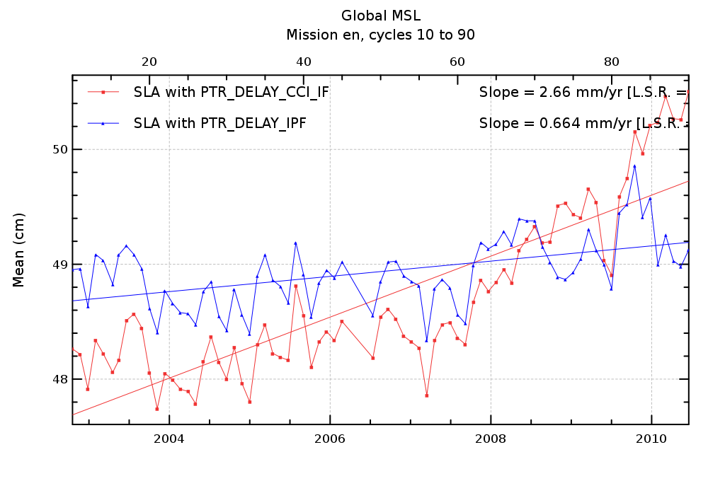  Temporal evolution of the global MSL with the new PTR correction only (red) and reference (blue) |  | For Envisat, the main evolution of the SLA is observed with the new PTR correction sign reversion. The impact of the reversion of the sign of the PTR correction can be seen on the global MSL trend (Δ=+2 mm/yr) when comparing the new PTR correction with PTR correction used in the historical RA-2 products.
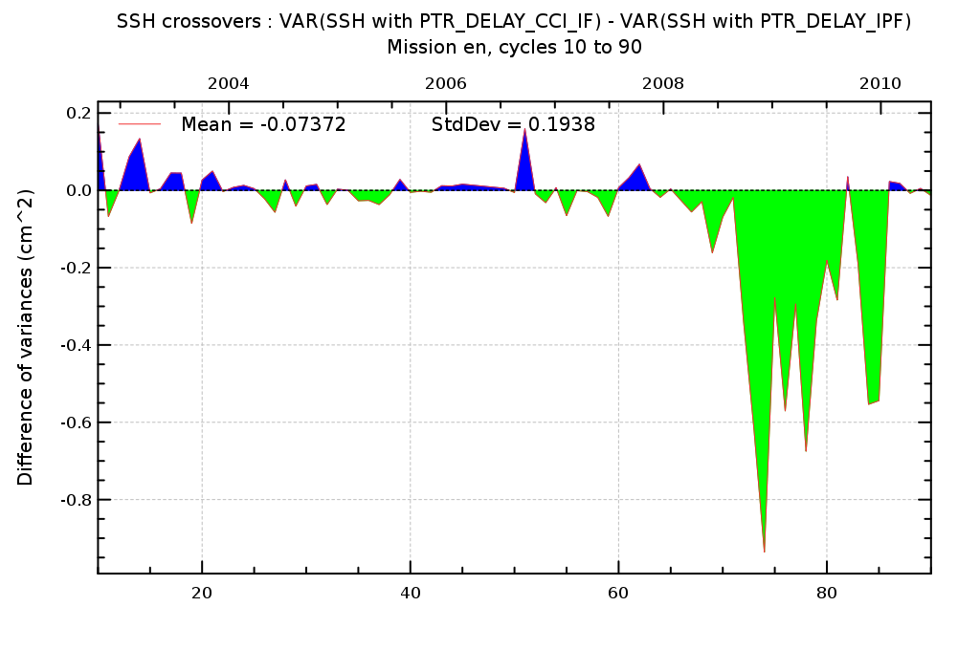  Temporal evolution of crossover SSH variance differences using successively new instrumental and reference corrections |  | We observe an improvement of the SSH variance when using the new CCI corrections mainly because the resolution of the PTR correction has been increased. At the end of the period, a jitter between 2 values of the PTR correction was observed on the reference products. This is no more the case with the new corrections inducing a better correction between increasing and decreasing passes.
Jason-1 MSL can be used as an external independent reference (Diagnoses B201) to assess the drift of the global MSL. The following table indicates the MSL drift difference between Envisat/RA-2 data and Jason-1 data including the CCI instrumental corrections on RA-2. A much better agreement can be seen now between both missions. The difference between the MSL was 1.73 mm/yr before the CCI study and is now around 0.3 mm/yr.
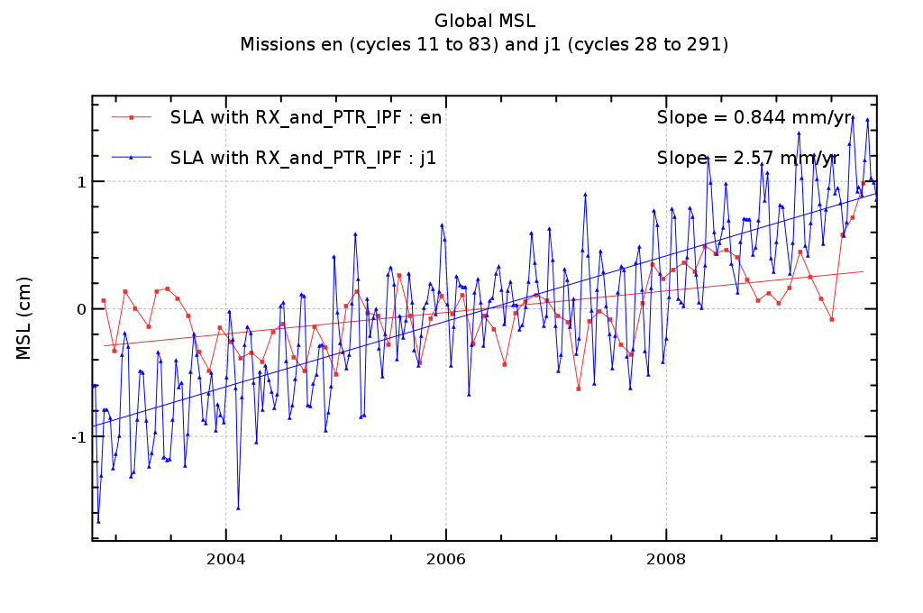 | 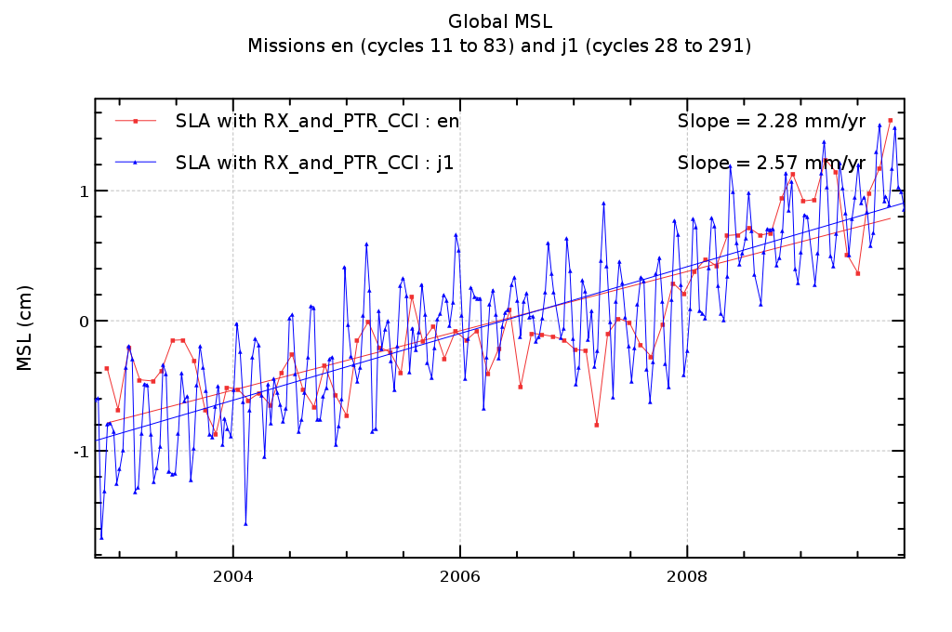
Temporal evolution of SLA anomaly for Envisat/RA-2 (including CCI corrections) (red) and Jason-1 mission (blue) (upper panel). Same plot with the RA-2 reference data on lower panel
Recommendations
The peculiarity of the instrumental correction is that we know that some instrumental features have to be accounted for and that we know (by theory) how to take them into account. Most of the time, we have no doubt on how to apply corrections. The main interest of this work is thus to quantify their impact on the various space and time scales and in particular their impact on the Global Mean Sea Level rise.
Improvement of the PTR (Point Target Response) instrumental correction resolution (Power of the PTR and Time_Delay). This improvement has been already taken into account by isardSAT in the RA-2 L1b IPF. RA-2 reprocessed products (IPF V2.1, 2011 RA-2 reprocessing activity)

- We recommend to keep this evolution which is also mandatory to observe small evolutions of the instrument due to ageing (at inter annual scale). To our point of view, it is clear that not taking these evolutions in consideration would induce a bad interpretation of inter-annual signals especially at the end of time series. A better resolution of the correction induces an improvement of the SSH variance at crossovers.

Inversion of the sign of the PTR Time_Delay Correction in Ku band. The SLCCI project is the first project that has analysed the impacts of this correction even if this evolution was proposed more than 2 years ago. The current RA-2 reprocessing activity doesn’t include this evolution because it was not mature enough and agreed by ESA at the beginning of the reprocessing.Based on strong hypotheses on the instrumental processing applied on-board on the waveforms and on the PTR data (sometimes very difficult to confirm 10 years after the launch), this evolution induces an important modification of the slope of the MSL of about +2mm/year that makes the corrected RA-2 global MSL much more coherent with the Jason one and also much more coherent with the tide gauges.

- From both MSL analyses and theoretical study we suspected an anomaly at the PTR level. This study assessed the proposed correction. We consequently clearly recommend to consider this PTR correction reversion and in the future to account for it in the next RA-2 reprocessing campaign.

Introduction of the IF filter effects in the PTR processing. PTR measurements account for the receiving chain of the altimeter. It is therefore necessary to correct the PTR measurements by the IF filter.

- There is absolutely no doubt that theoretically, this correction must be done even if the CCI study shows no impact on the MSL and only very small impacts on regional or small scales signals..

Improvement of the USO correction. This improvement has been already taken into account by isardSAT in the RA-2 IPF. Reprocessed products (IPF V2.1, 2011) account for this evolution. The USO correction that was computed in the RA-2 L1b was not correct. The CCI study has allowed to provide a L1b USO correction coherent with the USO correction computed previously in the RA-2 L2
- The recommendation is to use the USO correction which is the same from RA-2 level-1B IPF and Sea-level CCI project.

Final recommendation:
- When accounting for all these corrections, it has been showed that the RA-2 MSL is much more coherent with Jason MSL (difference of about 0.3 mm/yr) and with Tide gauges (difference of about 0.0475 mm/yr). In consequence, we recommend to apply all these corrections for future studies and to implement them (those that are not yet implemented) in the ground processing for future reprocessing campaigns.

Open issues
- To analyze ERS-1 and ERS-2 reprocessed data (REAPER project) with the same methodology and tools
- To be sure that TOPEX and Poseidon data reprocessing will account for instrumental corrections
- For all missions, to improve all instrumental parameters impacting SWH and Sigma-0 stability
- Based on Envisat experience feedbacks (RA-2 was not designed for climate objectives), how to anticipate the improvement of instrumental parameter corrections to guarantee the ability to use new missions for climate applications (Cryosat, HY-2A...)
Sea-level CCI ftp links
Validation report:
- SLCCI-ValidationReport_WP2100_InstrumentalCorrections.docx

RRDP reports:
- RRDP_WP2100_Instru_PTRDelayKu_IFCCI_vs_CCI_11-09-16.pdf
- RRDP_WP2100_Instru_PTRDelayKu_IFCCI_vs_IPF_11-09-16.pdf
- RRDP_WP2100_Instru_PTRDelayS_IFCCI_vs_IPF_11-09-16.pdf
- RRDP_WP2100_Instru_RxDelPTRDelayKu_CCI_vs_IPF_11-10-30.pdf
Technical references:
- Envisat-RA2_Drift_Analysis_V3.pdf
- Poster_PThibaut_OSTST_SanDiego_InstrumentalErrors.pdf

WP2200: Orbit calculations
WP2200: Orbit calculations
Objectives
To provide new orbit solutions for the main altimeter missions. Several orbit solutions have been developed by GFZ in the framework of the Sea-Level CCI project. Other orbit solutions provided by external groups as ESOC and CNES have only been evaluated. The orbit solutions are:
- Reaper combined orbits for ERS-1 and ERS-2
- ESOC Reaper orbits for ERS-1 and ERS-2
- GFZ Reaper orbits for ERS-1 and ERS-2
- GFZ SLCCI orbits for ERS-1, ERS-2
- CNES GDR-D orbits for Envisat, Jason-1 and Jason-2
- ESOC V7 orbits for Envisat and Jason-1

Key elements of choice
For Envisat and Jason-1:
Maps of regional MSL trend differences using successively the ESOC-V7, CNES GDR-D and CNES GDR-C orbit solutions highlight significant differences at regional scales. The impact is stronger for Envisat (±3 mm/yr) than Jason-1 (±1 mm/yr). Focusing at the regional MSL trend consistency between Jason-1 and Envisat after selecting the same period, this consistency is significantly improved between both missions using new orbit solution in the MSL calculation.
The large positive patterns observed using CNES CDR-C orbit in the West Pacific and in the Indian Ocean, have been significantly reduced with ESOC V7 or CNES-GDR-D orbits. However, it remains significant differences between both missions, but the spatial scale of patterns is smaller. Therefore it is likely due to the contribution of other altimetry components rather than the orbit as for instance the wet tropospheric or the ionospheric corrections.

Maps of MSL trend differences between Envisat and Jason-1 (over the same altimetry period) using successively CNES GDR-C (on left) and the CNES orbit GDR-D solutions (on right) in the MSL calculation
For ERS-1 and ERS-2:
The improvement of sea-level estimation for short temporal signal (> 20 days) is very significant using new Reaper and SLCCI orbits in comparison with the reference orbit (DEOS DGM-E04). The crossovers validation diagnoses display a very strong improvement for ERS-1 and ERS-2 in terms of variance reduction and geographical bias reduction. This strong improvement provided by new Reaper orbit is mainly due to the new standards used in the orbit calculation as the new model of the Earth gravity field. Comparing the Reaper orbits together, the best results are obtained with COMBINED solution with a significant variance reduction for both missions.
Comparing the GFZ SLCCI and COMBINED Reaper orbit solutions together, we also obtained a better consistency of sea-level calculation at crossovers with the COMBINED orbit. The following maps display clearly a global lower SSH variance at crossovers using COMBINED instead of GFZ SLCCI orbits. The temporal evolution of these variance differences does not depend on the period.

Maps of SSH variance differences using successively GFZ Reaper and DEOS (reference) orbit solutions in the SSH calculation for ERS-2 |  | Maps of SSH variance differences using successively GFZ SLCCI and Combined Reaper orbit solutions in the SSH calculation for ERS-2
Recommendations
For ERS-1 and ERS-2: on average the COMBINED Reaper orbits provide the best results for all the climatic applications with a significant improvement of the sea-level estimation in comparison with DEOS DGM-E04 orbit currently used in AVISO products. However, concerning some impacts on periodic signals or regional trends which are strong, we cannot determine which orbit solution is the best. For instance, the GFZ SLCCI orbit solutions containing new orbit standards (as ITRF2008) provide regional trends significantly different.
- Therefore we recommend to use the COMBINED Reaper orbit solutions since these orbit solutions display the best results in terms of consistency of ascending and descending passes as well as crossovers points as on long-term trends. However the GFZ SLCCI orbits solution clearly show interesting signals at basin scales which might be realistic.
For Envisat, Jason-1 and Jason-2: ESOC-V7 and preliminary CNES GDR-D orbit solutions significantly improves the estimation of regional sea-level trends with a strong reduction of longitudinal features (especially on Envisat). For the global MSL trend (only Envisat), we also detect a significant impact but it’s not possible to determine which orbit solution is the best. The impact on other climatic applications is null or low and it is also difficult to determine which orbit solution is the best.
- Although ESOC-V7 and preliminary CNES GDR-D orbit solutions provide similar improvements for scientific application, we recommend to use the preliminary CNES GDR-D orbit solution since it is available over a longer period until December 2012 included for Jason-1, Envisat but also Jason-2.

Open issues
- What is the best strategy for climate applications: to homogenize the orbit solutions for all the altimetry missions? or to chose the best orbit solutions for each altimetry missions ?
- TOPEX and GFO orbits have not been tested in the framework of the CCI project. Currently the GSFC orbit solutions are used for these both missions (2008). In OSTST 2011 (San Diego), new GSFC orbit solutions not yet available have been presented. They seem improve the TOPEX sea-level at climate scales. They could be tested within the CCI project.
- Final CNES GDR-D orbit solutions will be available in 2012 for Envisat, Jason-2 and Jason-1: it will be interested to use them in a next release of CCI products.

Sea-level CCI ftp links
Validation report:
- SLCCI-ValidationReport_WP2200_Orbits.docx
RRDP reports:
- RRDP_WP2200_Orbit_COMBINEDReaper_vs_GFZReaper_11-08-29.pdf
- RRDP_WP2200_Orbit_ESOCReaper_vs_GFZReaper_11-08-29.pdf
- RRDP_WP2200_Orbit_GFZReaper_vs_DEOS_11-08-26.pdf
- RRDP_WP2200_Orbit_GFZslcci_vs_COMBINEDReaper_11-09-06.pdf
- RRDP_WP2200_Orbit_ESOCv7_vs_CNESGdrC_11-08-26.pdf
- RRDP_WP2200_Orbit_CNESgdrD_vs_CNESgdrC_12-01-24.pdf
Technical references:
- ftp://dgn6.esoc.esa.int/reaper/poster_EGU-2011.pdf

WP2300: Wet troposphere correction
WP2300 & WP2700: Wet troposphere correction
Objectives
Most of the time, the wet tropospheric corrections used in the sea-level estimation are derived from on board microwave radiometer for all satellite altimeter. The correction can be also derived from models, however the performances of this correction are better when retrieved from instrumental measurements at a global scale, with respect to precision, sensitivity and spatial sampling. The modelled corrections are thus generally not used to calculate the best sea-level height but they remain one of the few references to assess the quality of the radiometric corrections in terms of performances or stability.
Several corrections have been evaluated :
- From models: ERA-interim, NCEP reanalyses, operational ECMWF (L2 products)
- From radiometers: GNSS-derived Path Delay (GPD) correction (University of Porto), composite correction (from CLS), radiometer correction (L2 products)
Notice that the GPD correction has been developed in the frame of Coastal Area work package (WP2700).
Key elements of choice
From models:
As expected, the use of all modeled corrections compared with the radiometer corrections generates a significant deterioration of the SSH at crossovers points. The deterioration depends on the period, on the mission and on the model. For TOPEX/Poseidon, we observe an average variance increase with models of 1.5 cm² with ERA Interim, 3.9 cm² with the operational ECMWF and 6.8 cm² with NCEP reanalyses. This demonstrates that ERA Interim provides the best performances before year 2000. After this time, the ECMWF operational model and ERA Interim have similar performances at crossovers with slightly better performance for ERA-interim.
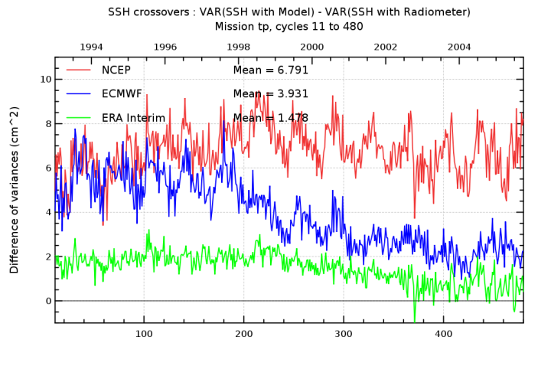 |  |  | 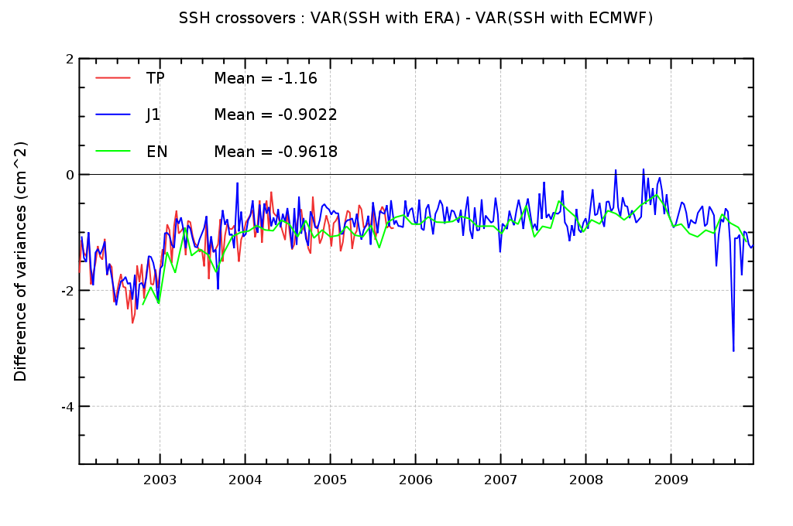
Monitoring of the SSH variance differences at crossover points with models versus composite correction for TOPEX/Poseidon (before 2005) |  |  | Monitoring of the SSH variance differences at crossover points with ERA-interim versus ECMWF (operational) from 2002 onwards for TOPEX/Poseidon, Jason-1, Envisat
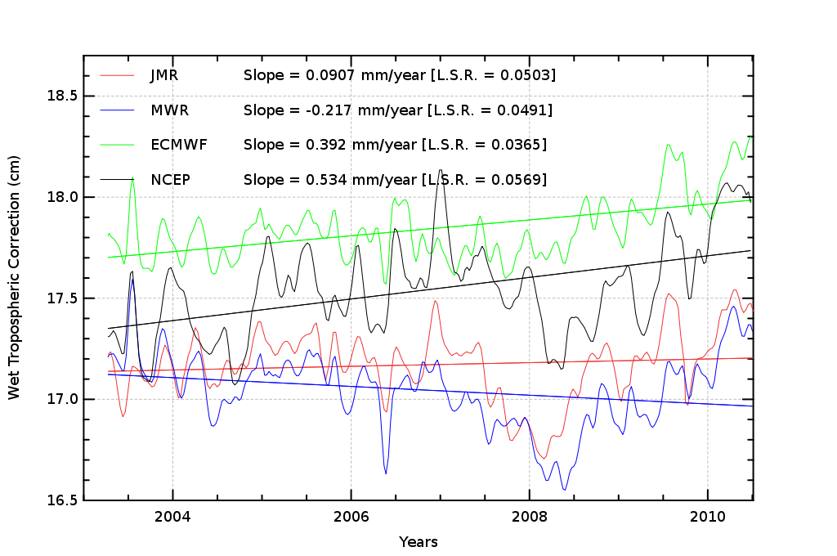  Monitoring of wet path delay (opposite of the wet tropospheric correction) for Jason-1 and Envisat radiometers, ECMWF,ERA and NCEP models |  |  | The difference of behaviour between ECMWF and NCEP corrections concerning this inter-annual effect of the 2008 ENSO event is also detected on the monitoring of the wet path delay as seen by radiometers, ECMWF and NCEP. NCEP reanalyses time series presents a similar evolution as radiometers in 2008 whereas ECMWF model doesn’t take into account this natural evolution of the water vapour content. As expected, the operational model doesn’t reproduce inter annual signal as well as with the NCEP reanalyses.
From radiometers : GPD algorithm
The GPD algorithm is based on the combination of zenith wet delays (ZWD) from three data types: Tropospheric delays derived at a network of coastal GNSS, ZWD from Envisat valid microwave radiometer measurements at the nearby points, ZWD from ECMWF.
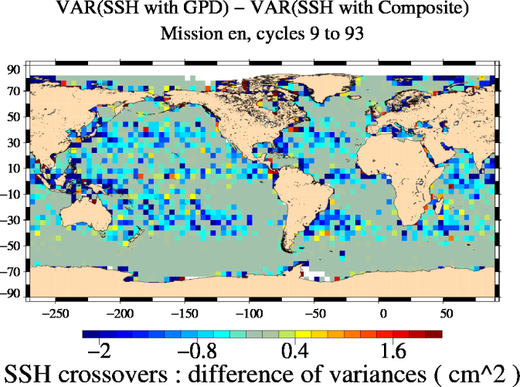 |  | The geographical distribution of the SSH variance differences at crossover points reveals an almost significant (1 cm²) improvement of the sea level variations at short temporal scales localized in the subtropical gyres and at equatorial latitudes associated with areas of highest variability of the water vapor content.
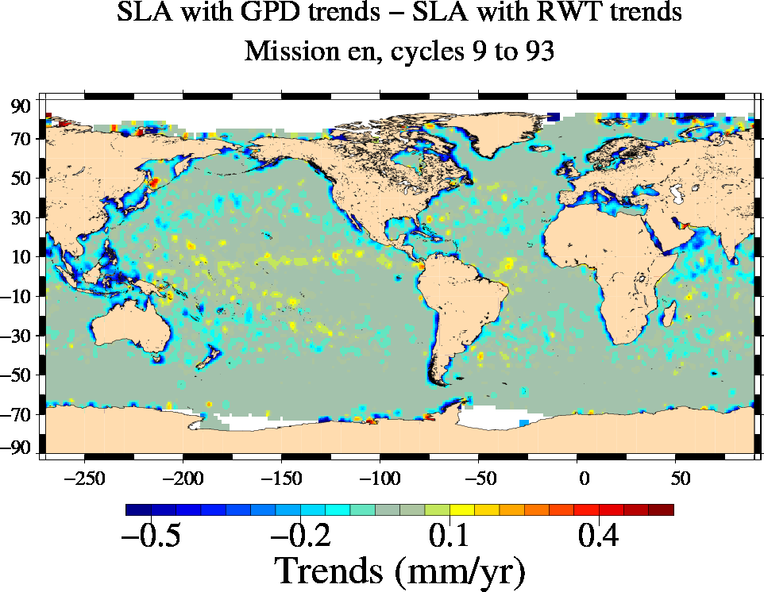 |  | The comparison between GPD and the radiometer wet troposphere correction shows significant impact (>0.5mm/yr) on the long-term evolution of the regional MSL localized in some coastal areas: Indonesia, Bering Strait, Labrador Sea and coastal areas of Spitsberg and of islands north of the Siberia coast). In these regions MSL trend is lower with the GPD correction. No significant impact is detected elsewhere.
Recommendation
From models:
In terms of long term stability, the use of ERA Interim and NCEP reanalyses have a similar impact compared with the composite reference correction and the analyses of the regional impacts suggest that ERA Interim reanalyses are preferred to assess the radiometers stability. In terms of Sea Level performances and estimation of short temporal scale signals, ERA Interim reanalyses provides the best wet tropospheric correction compared with others modeled corrections and is thus preferred to estimate the quality of radiometers. This choice, particularlyclear before year 2000 is still valid after this year in spite of the improvements implemented in the operational ECMWF since this year.

- We recommend to use the ERA-interim wet troposphere corrections to analyze the quality of the radiometer corrections for all the climate applications.

From radiometers: GPD algorithm
The GPD algorithm provides new estimations of the wet tropospheric correction in coastal areas. It has no impact on the global MSL trend estimation compared with the reference composite correction currently used in AVISO products. The MSL trend estimation is significantly modified in coastal areas with the GPD correction and it also improve the estimation of the sea level for mesoscale applications compared with the reference.
- Therefore we recommend to use the GPD algorithm for the estimation of the wet tropospheric correction for climate applications.
Open issues
- Currently the GPD algorithm is only available for Envisat: it could be completed for all the altimetry missions.
- Radiometer measurements are sometimes missing (TOPEX, Envisat, ...) due to anomalies: we could fill these gaps with models
- To be completed
Sea-level CCI ftp links
Validation reports:
- SLCCI-ValidationReport_WP2300_Wet Tropo.docx
- SLCCI-ValidationReport_WP2700_CoastalArea_WetTropo.docx
RRDP reports:
- RRDP_WP2300_WetTropo_ECMWF_vs_COMPOSITE_11-08-31.pdf
- RRDP_WP2300_WetTropo_ERAINT_vs_RWT_11-08-30.pdf
- RRDP_WP2300_WetTropo_ERAINT_vs_ECMWF_11-08-31.pdf
- RRDP_WP2300_WetTropo_NCEP_vs_COMPOSITE_11-08-26.pdf
- RRDP_WP2700_Coast_GPD_vs_Composite_11_08_30.pdf
- RRDP_WP2700_Coast_GPD_vs_Radiometer_11_08_30.pdf
Technical references:
- GPD algorithm: WP2710_Techical_Note_V1.docx

WP2400 : Ionosphere correction

Ionosphere correction
Objectives
To provide improved ionosphere corrections derived from altimetry or models. In the Sea-level CCI framework, new algorithms have been tested for ERS-1, ERS-2 and Envisat:
- The correction derived from NIC09 model is described in Scharroo R.,W. H. F. Smith, 2010, ”A GPS-based climatology for the total electron content in the ionosphere”, Journal of Geophysical Research, VOL 115, doi:10.1029/2009JA0014719. The code has been download at ftp://ibis.grdl.noaa.gov/pub/remko/nic09
- The GIM reprocessed correction. In 2010, as part as the RA-2 Envisat reprocessing activities the GIM Ionosphere correction has been reprocessed using up to date solar activity coefficients.
- A correction GIM adjusted on Jason-1: The correction consists in removing the low frequency component from the Envisat ionosphere GIM model to be replaced by the low frequency component of Jason-1 bi-frequency ionosphere correction.
Key elements of choice
For ERS-1 and ERS-2:
The MSL trend differences using NIC09 on ERS-1 and ERS-2 are significantly impacted at regional scales (A204): 6 to 0 mm/yr for ERS-1and -1 to 3 mm/yr for ERS-2. For ERS-1, the impact is stronger at low and mid latitude (along the geomagnetic equator) but, on ERS-2, some impacts are also noticed at high latitudes.

Maps of MSL trend differences using successively NIC09 and BENT/GIM (reference) ionosphere correction in the MSL calculation for ERS-1 (on left) and ERS-2 (on right).
For ERS-1:
There is a slight improvement of sea-level estimation for short temporal signal (< 20 days) using NIC09 instead of Bent correction (less than 1cm2 globally). On crossover diagnoses, the improvement is localized around South America and at low latitude in the Pacific Ocean. Moreover an annual signal is visible on the temporal evolution of the global variance difference: there is alternatively an improvement and degradation using the new correction. On the SLA variance difference, we observe as well an annual signal.
Maps and temporal evolution of SSH variance differences using successively NIC09 and Bent/GIM ionosphere correction in the SSH calculation for ERS-1
For ERS-2:
On ERS-2, the variance at crossovers is higher with NIC09 than with Bent/GIM, which can be explained by the fact that GIM performances are better. However the gain during the first period (when no GIM correction is available) is less obvious than for ERS-1. As for ERS-1, a similar annual signal is observed.
Maps and temporal evolution of SSH variance differences using successively NIC09 and Bent/GIM ionosphere correction in the SSH calculation for ERS-2
Recommendation
For ERS-1: the NIC09 correction improves the Sea Level for all scales. It has a big impact on the Global and regional Mean Sea Level, particularly for the year 1993, and a slight gain concerning mesoscale.
- Therefore we recommend to use the NIC09 for all applications

For ERS-2: the NIC09 or NIC09/GIM degrades the ascending/descending consistency for the global Mean Sea Level compared to the Bent/GIM correction, as well as the SLA variance.
- Therefore we recommend to keep the reference correction Bent/GIM

For Envisat: the tested algorithms have a very slight impact, which can be explained by the fact that among the 8 year of the Envisat series the algorithm are only applied to the 2 last years. However, the reprocessed correction use up to date solar activity coefficient and is expected to be of better quality. But we know that the GIM correction has not the stability required for Climate application: the difference of the GIM correction and the GIM adjusted on Jason-1 correction is 0.5mm/year over the whole Envisat period. This algorithm should then be considered as possibly efficient to correct a drift of the GIM model in the future years. However, since this algorithm is not available until the end of the studied period, it cannot be used here.
- Therefore we recommend to use the correction Dual frequency/GIM reprocessed (with updated solar activity coefficients)
Open issues
- Currently the GIM adjusted on Jason-1 is only available until June 2010: it could be completed for all the studied time period.
- The quality of the ionosphere model is not sufficient for climate application and is then one of the biggest issues for ERS-1, ERS-2, and the end of Envisat period.
- The transition between 2 corrections impacts on the consistency of the dataset. Is it better to use the same correction for the whole mission?
Sea-level CCI ftp links
Validation report:
- SLCCI-ValidationReport_WP2400_Iono.docx

RRDP reports:
- RRDP_WP2400_Iono_GIM_J1AJUST_vs_GIM_11-09-06.pdf
- RRDP_WP2400_Iono_GIM_REPROCESSED_vs_GIM_11-08-24.pdf
- RRDP_WP2400_Iono_NIC09_GIM_vs_BENT_GIM_11-08-24.pdf
- RRDP_WP2400_Iono_NIC09_vs_BENT_GIM_11-08-24.pdf

WP2400 Atmospheric corrections derived from pressure fields: dynamical atmospheric, inverse Barometer, and dry troposphere corrections

Atmospheric corrections derived from pressure fields
Objectives
To provide improved atmospheric corrections derived from pressure fields and used in the sea-level calculation: the Dynamical Atmospheric (DAC), the Inverse Barometer (IB) and the Dry Troposphere (DT) corrections. Several algorithms have been developed and evaluated :
- DAC, IB and DT corrections have been calculated from ERA-interim pressures fields (ECMW reanalyses). The evaluation has been performed for all the missions.
- IB and DT corrections have been calculated from NCEP reanalyses. The evaluation has been performed for all the missions.
- A new 70-day filtered DAC corrections has been developed in order to better remove the high frequency signal for Envisat, ERS-1 and ERS-2 missions

Key elements of choice
For DAC with ERA-interim :
The improvement of sea-level estimation for short temporal signals (< 2 months) is very significant using the DAC solutions derived from ERA-interim for ERS-1, ERS-2 and TP. DAC Era-interim allows reducing the residual variance at cross-overs by 10 cm² in the Southern Ocean where the high frequency response of the ocean to atmospheric forcing is very important. The reduction is also significant in the Arctic Ocean, north of Bering strait, and in the Hudson bay.
If looking at the temporal evolution of the crossover variance reduction, we note that ERA-interim has the greatest positive impact on the first years of the missions, then this impact diminishes until giving similar results as the operational DAC from year 2002. On the most recent years of the TP mission, we observe that both DAC have similar results in terms of crossovers variance reduction whereas the operational forcing had a slightly better resolution than Era-interim on this period: 0.5° versus 0.7°.

Map and temporal evolution of SSH variance differences at crossovers using successively the ERA-interim and operations ECMWF DAC solutions in the SSH calculation for TP

For 70-day filtered DAC:
The improvement of sea-level estimation for short temporal signals (< 2 months) is very significant using the 70-days filtered DAC for all missions concerned, ERS-2 and EN. Indeed this specific DAC has been performed to fulfill the Nyquist criteria of the 35-days sampling of these missions, and thus this correction allows removing more aliased high frequency signals in all high frequency variability regions (south-east Pacific and Indian, north of Pacific, Bering strait, north of Atlantic, Arctic ocean) and also in many shallow water regions (Patagonian shelf, Carpentaria sea, Thailand sea, Hudson bay, the Black sea, Red Sea, the Persian gulf, the North Sea ...). The crossovers variance reduction reaches 10 cm² in all these regions.
Map and temporal evolution of SSH variance differences at crossovers using successively the 70-days DAC and reference DAC solutions in the SSH calculation for ERS-2 (on left) and EN
Recommendation
The great interest of the ERA-Interim reanalysis for DAC, IB and Dry Troposphere corrections has been demonstrated. The improvement of sea-level using ERA-interim is maximum on first decade of altimetry due to the lower quality of operational ECMWF analysis during this period; this impact is also more important at high latitudes and in shallow waters where the atmospheric forcing is more energetic and the ocean has a strong dynamic response at high frequencies. On more recent missions, unexpectedly ERA-interim shows similar performances as the operational ECMWF analysis although the reanalysis has a wider spatial resolution. Note that the study also pointed out some strong impacts of ERA-interim on long-term scales but we could not determine if this impact is positive or not. NCEP reanalysis generally deteriorates results when compared to ERA-interim.
- We recommend to use ERA-interim on first altimetry decade for ERS-1, ERS-2, TP and GFO. For more recent missions, ERA-interim could also be used at least for long-term signals estimation.

The 70-day filtered DAC has a strong positive impact on the estimation of mesoscale signals in shallow waters and at high latitudes (southern Ocean, north Pacific, Arctic ocean) for the missions concerned, ERS-2 and Envisat. Indeed this specific DAC has been performed to fulfill the Nyquist criteria of the 35-day sampling of these missions, and thus this correction allows removing more aliased high frequency signals in all these regions. This correction has also a non negligible impact on the estimation of regional MSL.
- We recommend to use the 70-day filtered DAC for Envisat, ERS-2 and ERS-1 (35-day repetitive missions). However, we do not recommend to use it when those missions are used in a multimission context as a large wave length error correction can be used to correct the residual aliasing effect.
Open issues
The DAC correction is computed using a complex modeling, taking a high number of static and dynamic parameters/input, in particular:
- The bathymetry is one of the most important parameter of gravity waves modelling, in particular in the coastal areas. The bathymetry used in the operational DAC as well as in the ERA-interim DAC is mostly derived from new Gebco (1m grid). New global/regional bathymetry databases are now available and it would be interesting to analyze the impact of a new high resolution bathymetry on the DAC modelling. A new higher resolution mesh could also be tested.
- At the present time, no Sea Ice Cover is taken into account into the DAC modelling, but simulations could be improved (at high latitudes and seasonally at least) while using a varying sea-ice cover database: several databases are available and one need to chose the optimal one for the DAC computation (monthly climatology or even operationnal parameter).
- The wind-stress forcing could also be improved in the model thanks to the use of ECMWF wind-stress (including heat fluxes ...).
- As a recommendation of the CCI study is to use ERA-interim DAC for old missions, the continuity between ERA-interim DAC and the operational one need to be investigated.
- Some signals are not well resolved in the modeling as S1 and S2, due to the inadequacy of the atmospheric forcing. Increasing the frequency of the forcing fields would help us to better resolve these signals. Operationnal 3H forcing are available on ECMWF side, but preliminary tests performed recently did not show any improvement. Do better 3H operational forcing exists ? Do a 3H ERA-interim database exists ? What are its characteristics?
Sea-level CCI ftp links
Validation report:
- SLCCI-ValidationReport_WP2400-DAC-IB-DT.docx

RRDP reports:
- RRDP_WP2400_DAC_FILT70_vs_ECMWF_11-08-25.pdf
- RRDP_WP2400_DACera_vs_DACref_020911.pdf
- RRDP_WP2400_DryTropo_ERAINT_vs_ECMWF_11-09-16.pdf
- RRDP_WP2400_DryTropo_NCEP_vs_ECMWF_11-08-25.pdf
- RRDP_WP2400_IB_ERAINT_vs_ECMWF_11-025.pdf
- RRDP_WP2400_IB_NCEP_vs_ECMWF_11-08-25.pdf

WP2400 : Sea State Bias correction

Sea State Bias correction
Objectives
In order to improve the Sea State corrections, a new 3D non-parametric SSB model has been developed only for Envisat and compared to 2 existing 2D non-parametric SSB solutions which are the 2005 version currently and the 2007 version which will be available in the reprocessed Envisat data.
Key elements of choice
The impact of the 3D non-parametric SSB correction is significant concerning the estimation of the Envisat global MSL trend compared with the 2D non-parametric SSB correction currently used in the sea-level AVISO products (A201). The global MSL trend is decreased by 0.2 mm/yr for Envisat:
Altimetric mission | 2005 2D SSB | 2007 2D SSB | 3D SSB
Envisat | 0.69 mm/yr | 0.69 mm/yr | 0.49 mm/yr
Impact of the 3D non-parametric SSB correction on global MSL trend
The spatial distribution of the SLA variance differences between the 3D SSB and the currently used 2005 2D SSB correction reveals a strong variance reduction (>5 cm²) located in regions of high ocean variability. More locally, we also observe a variance increase along the North European coasts and in the northwestern Indian Ocean.
Most of the time, a variance reduction means that the new correction improves the SLA calculation. However in this case, the result is quite disturbing since the signature of the variance reduction is on the one hand very strong (which is not usual when assessing a SSB correction) and on the other hand very well correlated with the ocean circulation variability. Furthermore, we do not observe such similar results on SSH variance differences at crossovers. This means that only temporal scales higher than 10 days are concerned.
The observed strong variance reduction (except along some coastal areas) may not be an improvement, but an effect of the covariance terms between the SLA and both SSB corrections which could be significant. Currently, this hypothesis has not been demonstrated. But it is true, the diagnosis of variance reduction to estimate the SLA quality is likely not applicable.
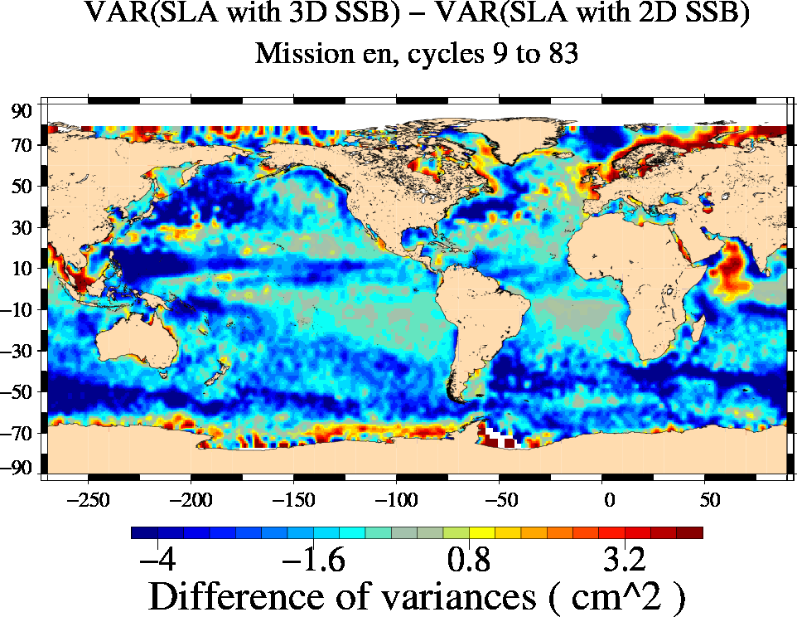 |  | 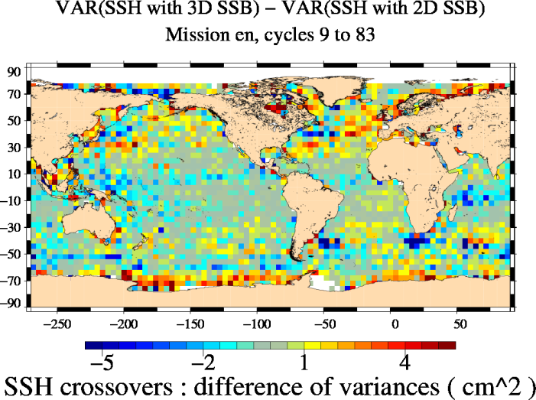
Recommendation
As expected, these analyses have confirmed that the 2007 version of the non parametric SSB correction is better than the currently used 2005 version particularly in terms of mesoscale applications (SLA performances).
Concerning the new 3D SSB correction, the impact is stronger for all the climate application with an impact close to 0.2 mm/yr on the global MSL for instance and higher than 1 mm/yr regionally. The spatial distribution of the SLA variance differences between the 3D SSB and the currently used 2005 2D SSB correction reveals a strong variance reduction (>5 cm²) located in regions of high ocean variability. Currently we are not able to determine if this SLA variance reduction shows an improvement or if it is an artifact for instance due to the covariance terms between the SLA and both SSB corrections which could be significant.

- Although the use of the 3D SSB correction in the MSL computation provides interesting improvement concerning some climate applications, we suggest to analyze the impact of this algorithm in more details before recommending its use for climate studies. Therefore, we recommend to use the 2007 version of the non parametric SSB correction.

Open issues
- To be completed
Sea-level CCI ftp links
Validation report:
- SLCCI-ValidationReport_WP2400-DAC-IB-DT.docx

RRDP reports:
- RRDP_WP2400_SSB_3D_vs_2D2005_11-09-05.pdf
- RRDP_WP2400_SSB_3D_vs_2D2007_11-09-05.pdf
Technical reference:
- SSB 3D: PhaseE_envisat_ssb_report_2010.pdf

WP2400 : Oceanic tidal models

Oceanic tidal models
Objectives
In order to improve the oceanic tidal model to improve the sea-level calculation for climate applications. The new GOT4V8 tide model have been analyzed in comparison with GOT4.7 and FES04 models
Key elements of choice
Considering the GOT4.8 and GOT4.7 differences, we clearly see the impact of the corrected S2 in GOT4.8. 58.74-day signal differences show a diminution reaching 0.5 cm in deep ocean; they are mostly localized at mid-latitudes.
If comparing GOT4.8 and FES 2004, many differences exist both in deep ocean and in all shallow waters; amplitude of these differences reach more than 0.5 cm.
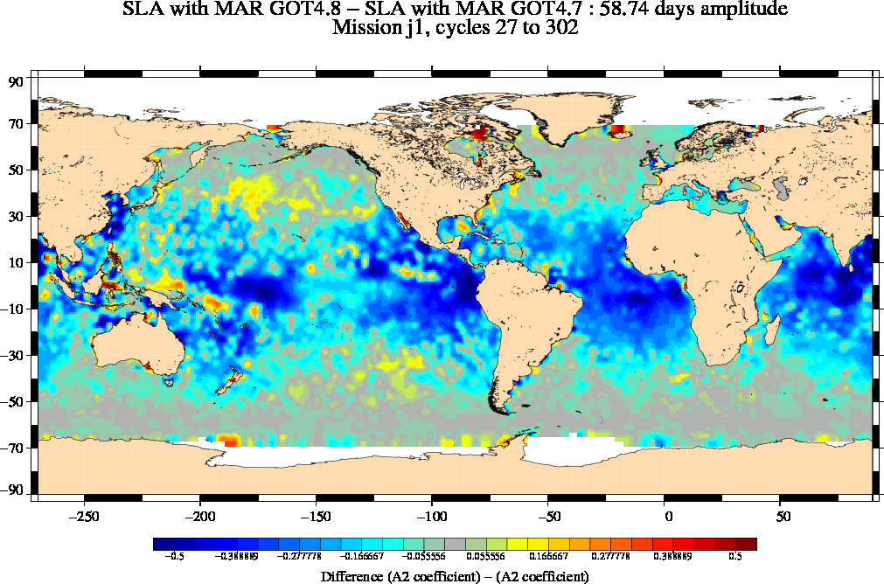

Differences of amplitudes of 58.74 days signal estimated from SLA corrected from GOT4.8 or GOT4.7, for Jason-1 mission (+/-0.5 cm). |  | Differences of amplitudes of 58.74 days signal estimated from SLA corrected from GOT4.8 or FES 2004, for Jason-1 mission (+/-0.5 cm).
 | Concerning GOT4.8 vs. GOT4.7 and Jason-1 results, the analysis shows clearly the impact of the S1S2 correction in GOT4.8: improvements are mostly localized between latitudes +/-40 and in some coastal areas (amplitude of 0.25-1 cm), which is coherent with the pattern of the difference between both models. We also notice a degradation of the solution in the Hudson Bay. Analysis on crossovers also shows the improvement of the new solution but not on the same areas due to the time differences (DT) of the crossovers differences which do not always allow observing properly the S2 signal, particularly in the equatorial region. The impact of the new model is very weak when using ENVISAT data due to its sun-synchronous characteristic. However, thanks to more appropriated crossovers DT in some areas, we notice a raise of the variance when using GOT4.8 model in the Hudson bay and in the Norwegian and the Barents seas; this degradation might be explained by errors due to ice cover.
Differences of SSH crossovers computed with the GOT4.8 model and with the GOT4.7 model for Jason-1 (on left) and Envisat (on right).

Recommendation
For the global ocean, the GOT4.8 model provides a small variance reduction on global ocean compared to GOT4.7, but a weak degradation is also detected in the Hudson Bay and in the Norwegian and the Barents seas. However, using GOT4.8 allows us to reduce 58.74-days signal estimated on MSL compared to GOT4.7 although this signal remains still stronger than if using FES 2004.

- For Global ocean, we recommend to use GOT4.8 tidal model

Notice that in WP2700 dedicated to high latitudes areas, we studied the impact of 2 others oceanic tide models: DTU10 and TPXO. The analysis of the impact of these both models is performed in the dedicated validation report: SLCCI-ValidationReport_WP2600_HighLatitudes.docx. In this report, we recommend to use the DTU10 tidal model in the Arctic area and northern very high latitudes regions.

Open issues
- Interaction with Monarch (ESA project)
- To be completed
Sea-level CCI ftp links
Validation report:
- SLCCI-ValidationReport_WP2400-TidalModels.docx

RRDP reports:
- RRDP_WP2400_Tide_GOT4V8_vs_FES04_11-08-25.pdf
- RRDP_WP2400_Tide_GOT4V8_vs_GOT4V7_11-08-25.pdf

WP2500: Regional SSH bias corrections between altimetry missions
WP2500: Regional SSH bias corrections between altimetry missions
Objectives
A main source of error to calculate the global or the regional Mean Sea Level (MSL) trends is the uncertainty to link together all the altimetry missions in order to provide a continuous MSL time series from 1993 onwards.
A very strong effort has been already done to link together as well as possible the global MSL altimetry missions deduced from TOPEX/Poseidon (T/P), Jason-1 and Jason-2. Currently, the uncertainty due to this global bias is close to 0.2 mm/yr. Concerning the regional MSL bias at basin scales, systematic geographical biases between altimetry missions have been already detected and not taken into account (except between Jason-1 and Jason-2) to calculate sea-level maps over all the altimetry periods. These errors could impact directly the regional estimation of the MSL trends with a potential effect locally higher than 1 mm/yr, which is significantly stronger than for the global MSL (0.2 mm/yr).
Therefore, the objective is to provide new corrections containing the regional MSL biases between NASA/CNES missions (T/P, Jason-1, Jason-2).
Key elements of choice
For TOPEX/Jason-1:
In order to correct the hemispheric bias observed between both missions, the SLA differences (without correction except the SSB) are calculated during the Jason-1 verification phase by band of latitudes, selecting all the passes and separating ascending and descending passes since the behavior of ascending and descending passes is opposed in each hemisphere (with a similar feature close to the equator).
The SSH bias correction to adjust the TOPEX SSH on the Jason-1 SSH is :
With for ascending passes :
And for descending passes:
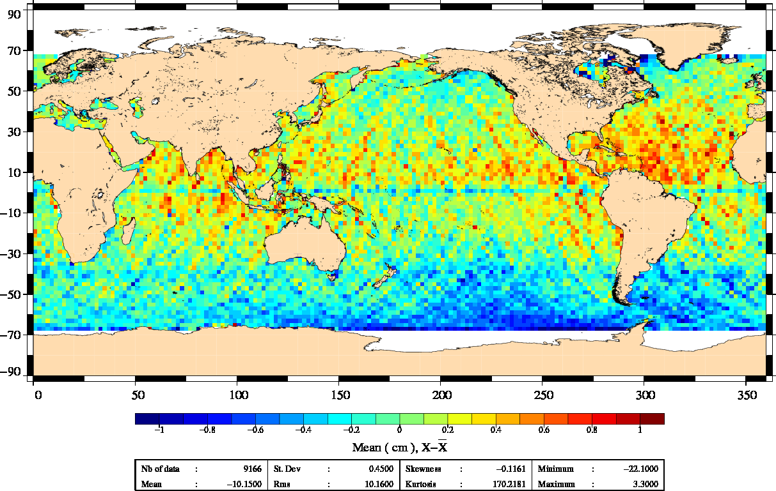 |  | 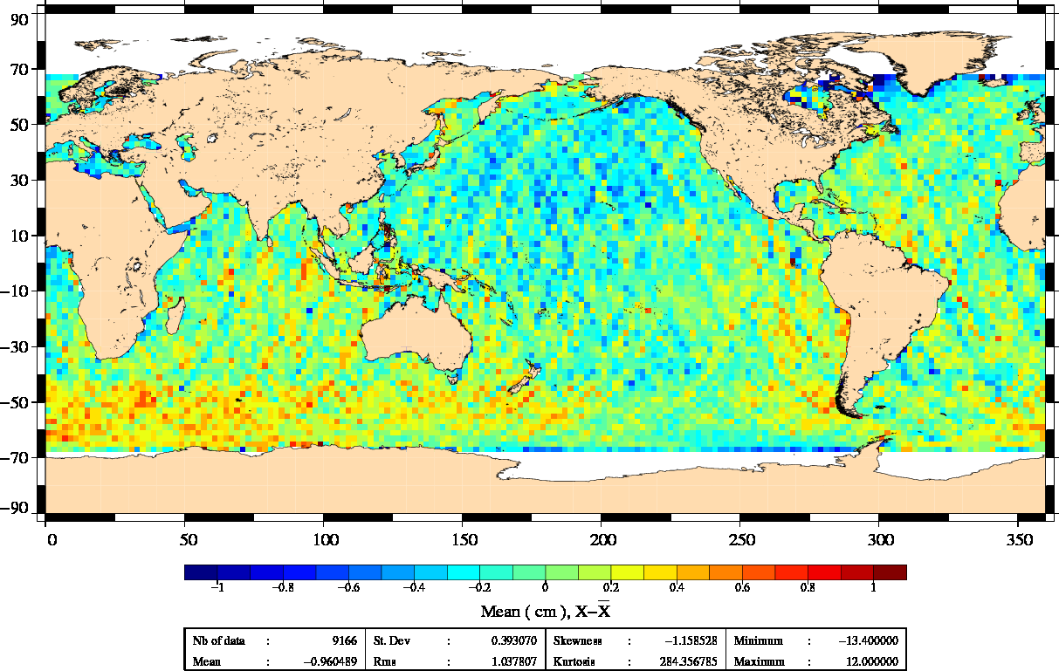
Map of SLA differences between TOPEX and Jason-1 without applying the regional correction (just centered on the average) on left and after applying it on right.
For Jason-1/Jason-2:
The SSH bias correction to adjust the Jason-2 SSH on the Jason-1 SSH is :
With:

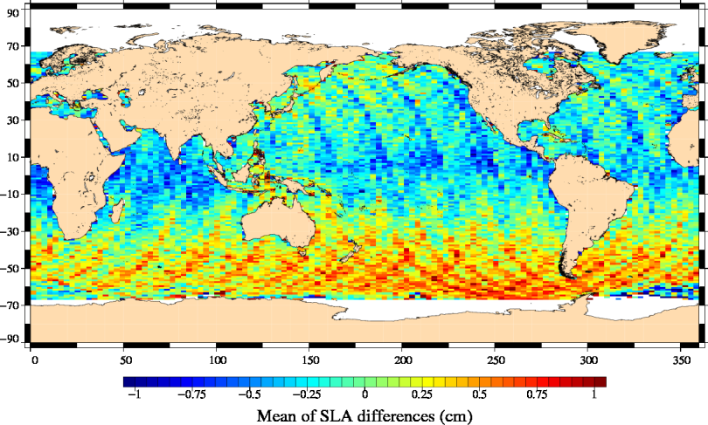 |  | 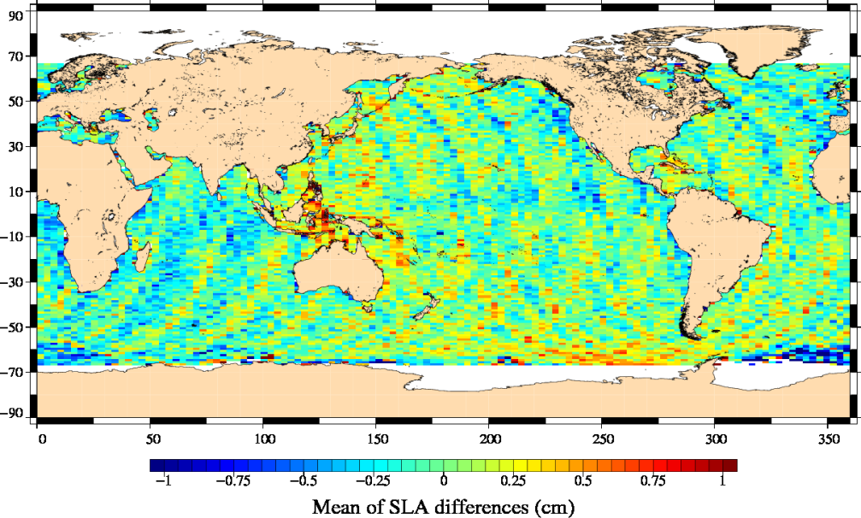
Map of SLA differences between Jason-1 and Jason-2 without applying the regional correction (just centered on the average) on left and after applying it on right
Recommendation
The impact of empirical regional bias corrections proposed to better link
Jason-1/Jason-2 and TOPEX/Jason-1 MSL has been analyzed calculating the MSL trends from 1993 to 2010 and applying or not the regional bias corrections. The MSL trend differences range from -0.2 to +0.3 mm/yr from North to South. Considering ascending and descending passes separately, differences are higher from -0.5 to +1 mm/yr.
Notice that these new corrections have no impact on the global MSL trend as displayed. A very slight annual signal (lower than 0.2 mm of amplitude) is observed on global MSL differences. Indeed, the application of a grid correction (constant temporally but not spatially) generates an annual signal due to the annual data coverage variation in relationship with ice sea coverage (especially in northern hemisphere).
- We recommend to use the regional MSL bias correction to link together the TP, Jason-1 and Jason-2 missions.
Open issues
- Notice that these empirical corrections strongly depend on the altimetry standards used on the Jason-1 or TOPEX MSL calculation. If one of them is modified, especially concerning the orbit calculation, coefficients of the polynomial function should be revisited.
Sea-level CCI ftp links
Validation report:
- SLCCI-ValidationReport_WP2500_AltimetrySSHBiasBetweenMissions.docx

WP2500: Merging algorithm: mapping method
Merging algorithm: mapping method
Objectives
The gridded Essential Climate Variable product is computed using several missions. The objective of this document is to analyse the sensitivity of two mapping algorithms to compute the multimission gridded product. The time and space resolution required for the product in the SLCCI is respectively 1 month and 25 km (see the URD and PSD document). However several of the dataset tested are at different space time resolution, in order to show the sensitivity of the result to these parameters.
For this study we have used three existing AVISO datasets:
- DS0: The Ssalto/DUACS gridded product by Optimal Interpolation weekly and 1/3° resolution using all the altimetry missions. This product is a product dedicated to multipurpose application, including mesoscales. We have used this dataset as the reference dataset.
- DS0_TPJ1J2: Same as DS0 but computed from 1 mission only. This dataset was used for the comparison with the Reference Mean Sea Level time series from Aviso (computed with the T/P-Jason-1-Jason-2 series)
- DS1: Monthly mean (temporal mean) keeping the 1/3° resolution. This product is deduced from DS0 by computing the mean of the weekly maps for each month.
- DS2: Monthly mean of spatially filtered fields (1000/500km cut off in longitude/latitude) and averaged at 1° deduced from DS0. This product has been supplied available for use in the next IPCC assessment (AR5) via the CMIP5 experiment as SSH observational data.
Then we have produced 2 new datasets:
- DS3: Simple direct boxed mean of along track SLA monthly and 1° resolution.
- DS4: Direct Optimal Interpolation monthly and 1°/3 resolution
Key elements of choice
Firstly, regarding the Global MSL trend application, the MSL trend obtained from DS0_TPJ1J2 is lower than the AVISO MSL trend by 0.1mm/year. Moreover, on the AVISO reference curve, the noise level is greater than when using a mapping method which acts as a filter. As shown by the comparison on the filtered AVSIO reference curve with the DS0_TPJ1J2, this high frequency can slightly affect lower frequency signal estimation. At this time, the higher accuracy of MSL deduced from gridded products is not clearly evidenced. The global MSL trend obtained with the other maps datasets are similar, indicating that no specific methodology for maps construction should be used for global long term MSL applications. DS3 is slightly different from the other series, and closer to the AVISO reference MSL trend.
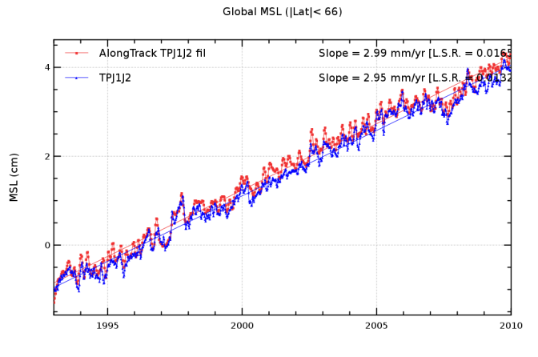
MSL trend of the along track TP/J1/J2 time series filtered with a 2 month filtering cut off Period and the TP/J1/J2 map time series (not filtered)

Secondly, the result shows that the monthly temporal sampling doesn’t significantly impact the regional MSL trend estimation, whatever the method used (DS1 or DS4). Some localized impacts are observed on DS4 results in the Tropical Pacific and at high latitudes. On the contrary, on the configuration at 1° spatial resolution DS2 and DS3 the MSL regional trends is strongly impacted in the high variability areas compared to DS0. Moreover, for those 2 series, differences with DS0 underline also “streaks” like structures. Amplitude differences are usually lower than ±0.6 mm/year for DS2, lightly higher for DS3. The same conclusion is obtained considering the annual and semi annual signals: amplitude/phase differences obtained with DS1 and DS4 are weak except locally and the one obtained with DS2 and DS3 are rather strong.
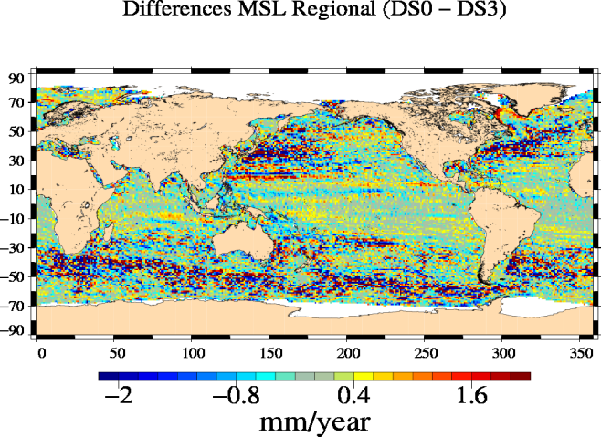 |  | 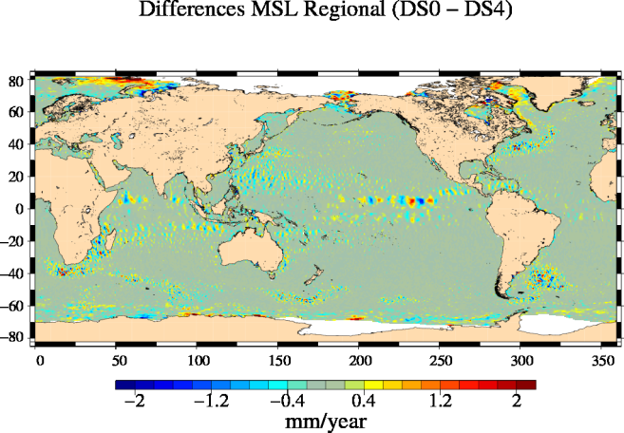
Differences of regional MSL trend observed with DS0 and others datasets over [1993,2009] period.
 | Finally, comparison of different methodologies for maps construction and different maps spatial/temporal resolutions clearly underline the inability of low spatial resolution maps to reconstruct part of mesoscale signal, and its inter-annual variability which may be of interest for Climate applications. In some part of the ocean, a major part of the signal is even absent when using a low spatial resolution. Climate products should thus be constructed with spatial resolution not lower than 1/3°x1/3. The mapping method to use cannot thus be a box averaged method. An OI methodology, or equivalent, should thus be privileged.
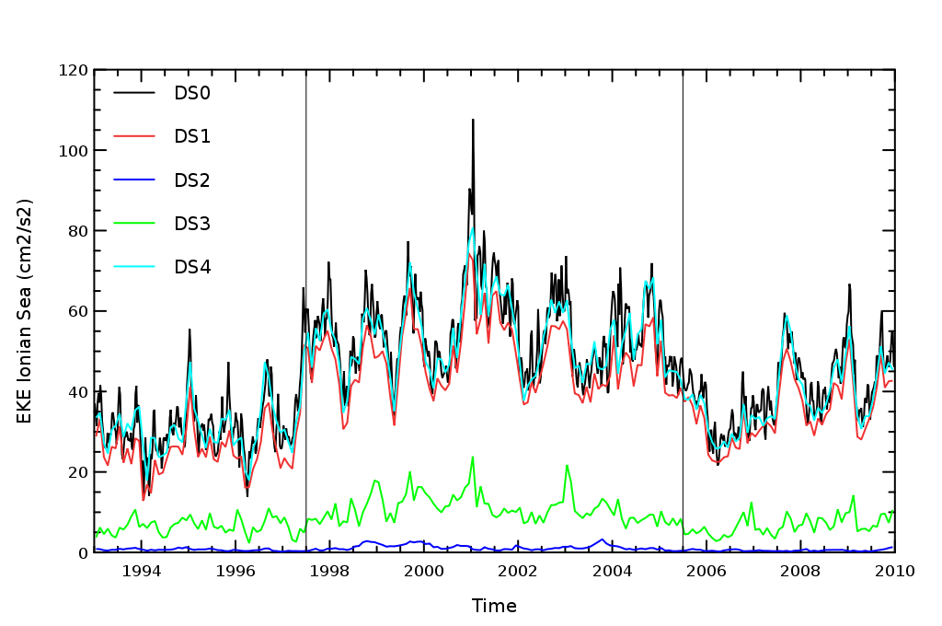
Temporal evolution of the mean EKE in the central Ionian Sea.
Recommendation
This study clearly underlined that the different mapping methodologies considered don’t lead to the equal reconstruction of signal required for climate applications.
- The impact on global MSL trend is actually very low. No specific methodology needs thus to be privileged for this application.
- The impact on regional MSL is higher. The datasets produced with a box average method or with a too smooth content does not allow to accurately retrieve the regional MSL. For this application, an OI method is recommended.
- The impact on regional Mean Sea Level is strong. The 1°x1° resolution is clearly not sufficient to resolve the mesoscale signals and to detect its inter-annual variations. 1/3°x1/3° resolution allows us to resolve a large part of these signals. The mapping method to use can not thus be a box averaged method (see appendix). An OI methodology, or equivalent, should thus be privileged. Using a monthly OI method (1/3°) dataset does not obviously allow us to reconstruct the mesoscale signals, but allows us at least to monitor the inter-annual variability of the mesoscale energy, and to accurately map the permanent fine scale structures.

- We recommend to use an Optimal Interpolation method to compute directly the SLCCI ECV at resolution of 1 month and 1/3°
- This include the map dataset and the Global Mean Sea Level time series
Open issues
- Investigate the Regional MSL differences obtained with Monthly OI method (DS4), notably in the Tropical Pacific Ocean.
Sea-level CCI ftp links
Validation report:
- SLCCI-ValidationReport_WP2500_MappingMethod.docx

WP2500: Impact of altimeter satellite constellation
Merging algorithm: mapping method
Objectives
The gridded Essential Climate Variable product is computed using several missions. The objective of this document is to provide results on the first study, the impact of the missions used in the mapping. The interest of this analysis is twofold. First, the analysis of the differences between the various datasets produced using different combination of satellites will give us information on the interest of using a multimission dataset: what is the difference of using 1 sat (TP/J1/J2 series), 2 sat (the Ref series: TP/J1/J2+ERS1/ERS2/Envisat), 3 or 4 satellites (The Ipd series: Ref Series+GFO+TPN+J1N) in the merging process? Secondly, it will also bring information on the residual unhomogeneity between the missions used for the merging, and thus will allow us to highlight the defects of the homogenization process.
Key elements of choice
1 sat (TP/J1/J2) versus 2 sat (Ref)
The global MSL trend obtained from TPJ1J2 maps or REF maps give very close results, within 0.1mm/year, when estimated over 18 years (1993-2010). The difference between the Ref maps and the TPJ1J2 maps in 1994 (up to 4mm) is due to an anomaly on the Ref series, caused by the use of erroneous ERS-1 Sea Level Anomalies during the Geodetic Phase.
On regional trend differences over 1993-2010 we observe long wave length (up to several thousand km) features correlated with the ionosphere correction with amplitude lower than 1mm/year. When estimated over a 10 year period (2000-2010), this signal becomes clearer, with amplitude greater than 1mm/year, with two bands of negative trend differences along the geomagnetic equator. This difference highlights a residual error in the Ref dataset. the Ref maps are computed combining T/P data, processed using a dual frequency ionosphere correction (except on Poseidon cycles), and ERS-2 data corrected from ionosphere effects using the GIM model ionosphere correction. The model correction is known to be less accurate than dual frequency corrections so we can suppose that this signal is the residual signature of an error in the ERS-2 SLA used to compute the Ref maps. ERS-2 data are notably used to compute the Ref maps during the years 1999-2001 when the solar activity reaches a maximum.

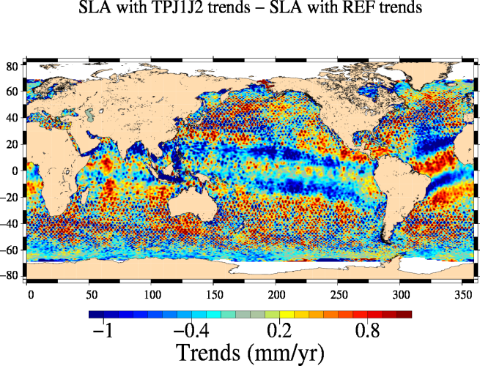 |  | 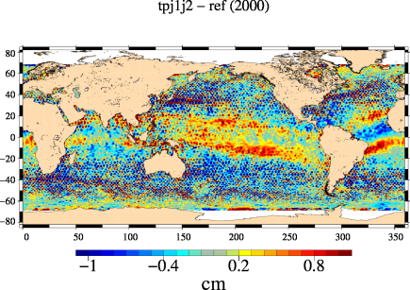
Map of difference of regional MSL trend on 2000-2010 for TPJ1J2 / Ref series (left) and map of mean difference of MSL over 2000 (right)
2 sat (Ref) versus 3 or 4 sat (Upd)
The MSL trend obtained from Upd maps or Ref maps give the same results
The Upd-Ref regional MSL difference are strongly lower than for the TP/J1/J2 versus Ref comparison, at short scales but also at larger scales. When estimated over a 10 year period (2000-2010), the differences remain very weak in general but are significant very locally: the ionosphere pattern described earlier is slightly visible also here, and in the North of the Indian Ocean a negative differences between -0.3 and -0.6mm/yr is observed over a large area. Moreover differences are also visible in the Arctic Ocean. At these latitude, the ref maps are computed using ERS-1/2/Envisat missions (covering latitudes -82°/82°) whereas the Upd maps use additionally the GFO mission (covering latitudes -72°/72°). The introduction of GFO induces regional mean sea level trend differences between 66°N and 72°N. As shown by Figure 6 b, the average of the Mean Sea Level trend difference in this latitude band is about 1mm/yr: the use of GFO induces a lower mean Sea Level trend than when using ERS-2 or Envisat only. It is not obvious to determine if GFO improves or degrades the MSL estimation.
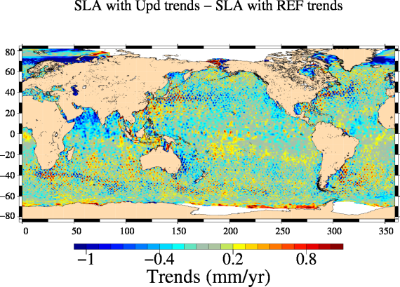 |  | 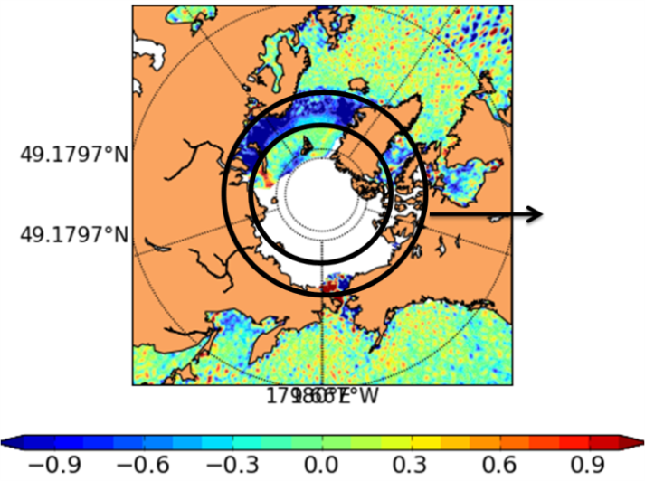
Map of difference of regional MSL trend on 2000-2010 for Upd / Ref series (left) and map of mean difference of MSL over 2000 (right)
Recommendation
The quality of the TP/J1/J2 series is optimal at mid and low latitude. The Upd degrades the Sea Level around the geomagnetic equator due to errors in the ionosphere correction of ERS-1/2 series but allows to cover the high latitudes and is the best configuration for mesoscale application.
- We recommend to use a Upd configuration
Open issues
- The ionosphere correction of the mono frequency satellite contains large errors that can contaminate a multimission merged dataset. A correction has to be studied, at level 2 or level 3 during the homogenization process
- Deep investigations on secondary band might also be necessary for Envisat
- Improvement of multimission homogenization is also needed at high latitude.
Sea-level CCI ftp links
Validation report:
- SLCCI-ValidationReport_WP2500_ImpactMissionUsed.docx

RRDP reports:
- RRDP_WP2500_MultimissionMerging_Ref_vs_TPJ1J2_11-08-15.pdf
- RRDP_WP2500_MultimissionMerging_Ref_vs_Upd_11-08-15.pdf
- RRDP_WP2400_DAC_FILT70_vs_ECMWF_11-08-25.pdf

WP2600: High latitudes areas
High latitudes areas
Objectives
To provide a better estimation of sea-level estimations at high latitudes where the SLA performances could be reduced due to ice coverage.
In the framework of the Sea-level CCI project, analyses have been focused on dedicated tidal oceanic models in Arctic Ocean (TPX07.2 and DTU10), and new Mean Sea Surfaces significantly improved at these latitudes (CNES/CLS 2011 and DTU2010).
Key elements of choice
Tidal models:

TPXO7.2 reduces the along-track SLA variance in the Arctic Ocean, north of Russia and Alaska, but it raises the variance in other coastal regions. Elsewhere in deep ocean results are similar to GOT4.7. DTU10 reduces the SLA variance in most of the Arctic Ocean and in northern part of Baffin bay; in northern Pacific and Atlantic oceans, DTU10 raises the residual variance if compared to GOT4.7.

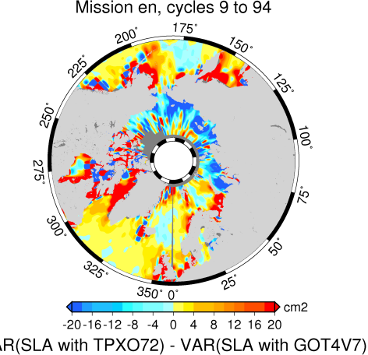 |  | 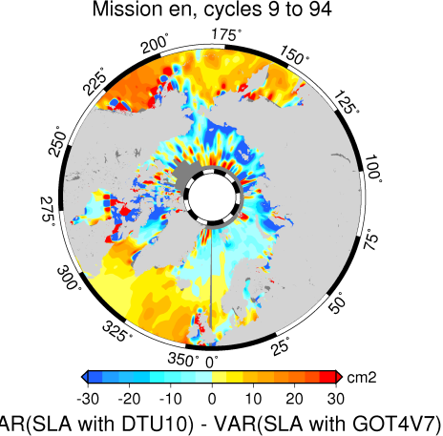
Differences of SLA respectively computed with TPXO7.2 and GOT4.7 on left and DTU10 and GOT4.7 on right for Envisat.
Mean Sea Surfaces:
Maps of SLA variance differences reveal that performances are deteriorated with MSS DTU10 in winter with a maximum of ice coverage (+1.9 cm2) whereas they are significantly improved with this MSS in summer with the minimum of ice coverage (-6.2 cm2). Nevertheless, same maps suggest that in the studied area, this significant improvement is associated with a very restricted zone at high latitudes (blue area) which is not seen by the altimeter in winter where performances are strongly improved with DTU10.

Figure |  | figure
Difference of variance of SLA with MSS DTU10 referenced to the 7 years 1993-99 and MSS CNES/CLS 11 over Envisat cycle 61 in September 2007 (left) and Envisat cycle 56 in March 2007 (right).

Recommendation
Tidal models:

At high latitudes, the DTU10 tidal model in the Arctic area and northern very high latitudes regions provides a strong SSH variance reduction in these regions and it has also a significant impact on regional MSL (+/- 1 mm/yr).

- Therefore, concerning high latitudes we recommend to use the DTU10 tidal model in the Arctic area and northern very high latitudes regions

Mean Sea Surfaces:
Both MSS (DTU10 and CNES/CLS 2011) are complementary since at very high latitudes the DTU10 MSS provides better SLA performances whereas elsewhere (in open ocean) the CNES/CLS11 MSS is better.

- Therefore, we recommend to use the DTU10 MSS in order to favour the Arctic Ocean which is an area of main interest for climate studies. On the other hand, the use of the DTU10 MSS instead of CNES/CLS 2011 MSS reduce the SLA performances in open ocean which could have an impact on mesoscale applications. However, as the Sea-Level CCI products (ECV) are monthly products dedicated to climate studies, this impact will be very low.

Open issues
- To generate a MSS over a 20-year period in order to better take into account the inter-annual oceanic variability, and in fine to calculate more realistic sea level anomalies from a climate point of view.

Sea-level CCI ftp links
Validation report:
- SLCCI-ValidationReport_WP2600_HighLatitudes.docx

RRDP reports:
- RRDP_WP2600_HiLat_Tide_TPXO7V2_vs_GOT4V7_11-09-15.pdf
- RRDP_WP2600_HiLat_Tide_DTU10_vs_GOT4V7_11-09-15.pdf

Technical Documents:
- MSS CNES/CL 2011 and DTU2010 comparison: SALP-NT-P-EA-22034-CLS-1-0.pdf

WP2700 : Coastal areas
Coastal areas
Objectives
In order to improve the sea-level calculation for coastal areas for climate application, 2 new algorithms has been developed within the Sea-Level CCI project:
- New wet troposphere correction: GNSS-derived Path Delay (GPD) correction (University of Porto)
- Coastal proximity parameter (NOC)

Key elements of choice
Wet troposphere correction (GPD):
The GPD wet tropospheric correction provides a strong improvement (2 cm²) of the Sea Level anomalies (referenced to a MSS) in coastal regions inshore 50 km (reduction of the SLA variance) for Envisat mission compared with the composite wet troposphere correction (ECMWF+radiometer). The improvement is reduced to 0.3 cm² between 50km and 100km from the coast. This variance reduction is not as clear when the comparison is performed with the radiometer wet troposphere correction only (available on L2 product) although a SLA variance reduction close to 0.5 cm² is observed but not dependent on the coast. Notice that the statistics for coastal distance lower than 15 are not significant due to the low altimetry number measurements.
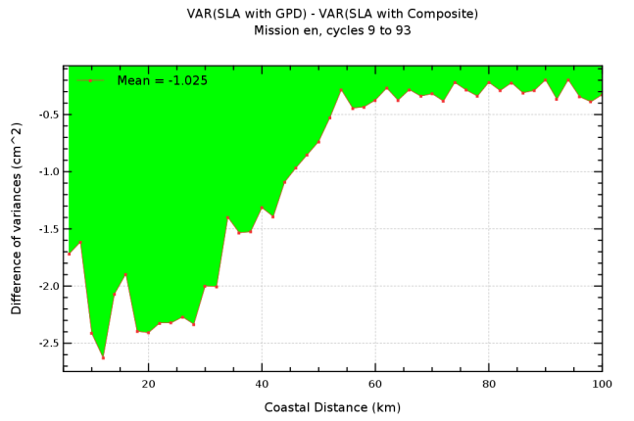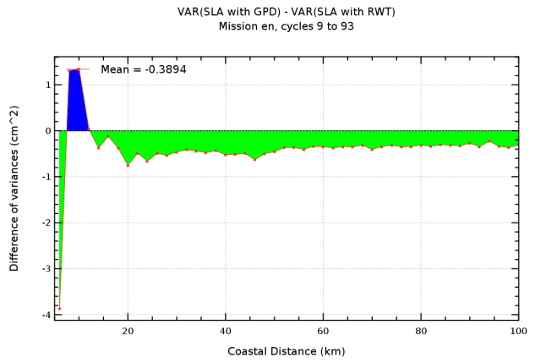
Figure 12: [Diagnosis A208] SLA variance difference versus coastal distance comparing the GPD versus composite correction (left) and the GPD versus radiometric correction (right).
Coastal proximity parameter
A new coastal parameter has been developed in the frame of the Sea-Level CCI project in order to better capture differences in coastal morphology. This parameter (P), is expected to improve screening: impact on the regional variability in coastal regions. This parameter available on a 2D-grid (0.02 deg), is not a correction of the SSH calculation as all the other algorithms developed within the project. It can be used as an auxiliary data to improve some algorithms as for instance the editing procedure to remove spurious measurements in coastal areas. Therefore, the diagnoses of validation defined in the PVP document are not applicable for this algorithm and the coastal proximity parameter has not been evaluated.
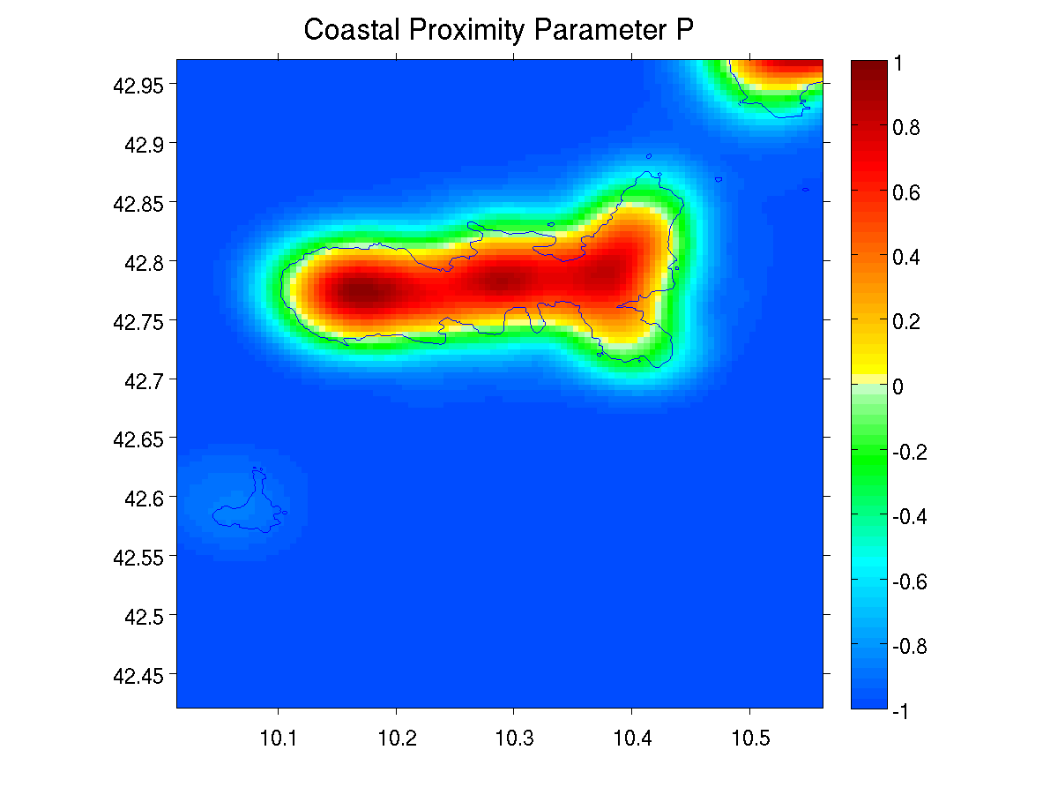 |  | 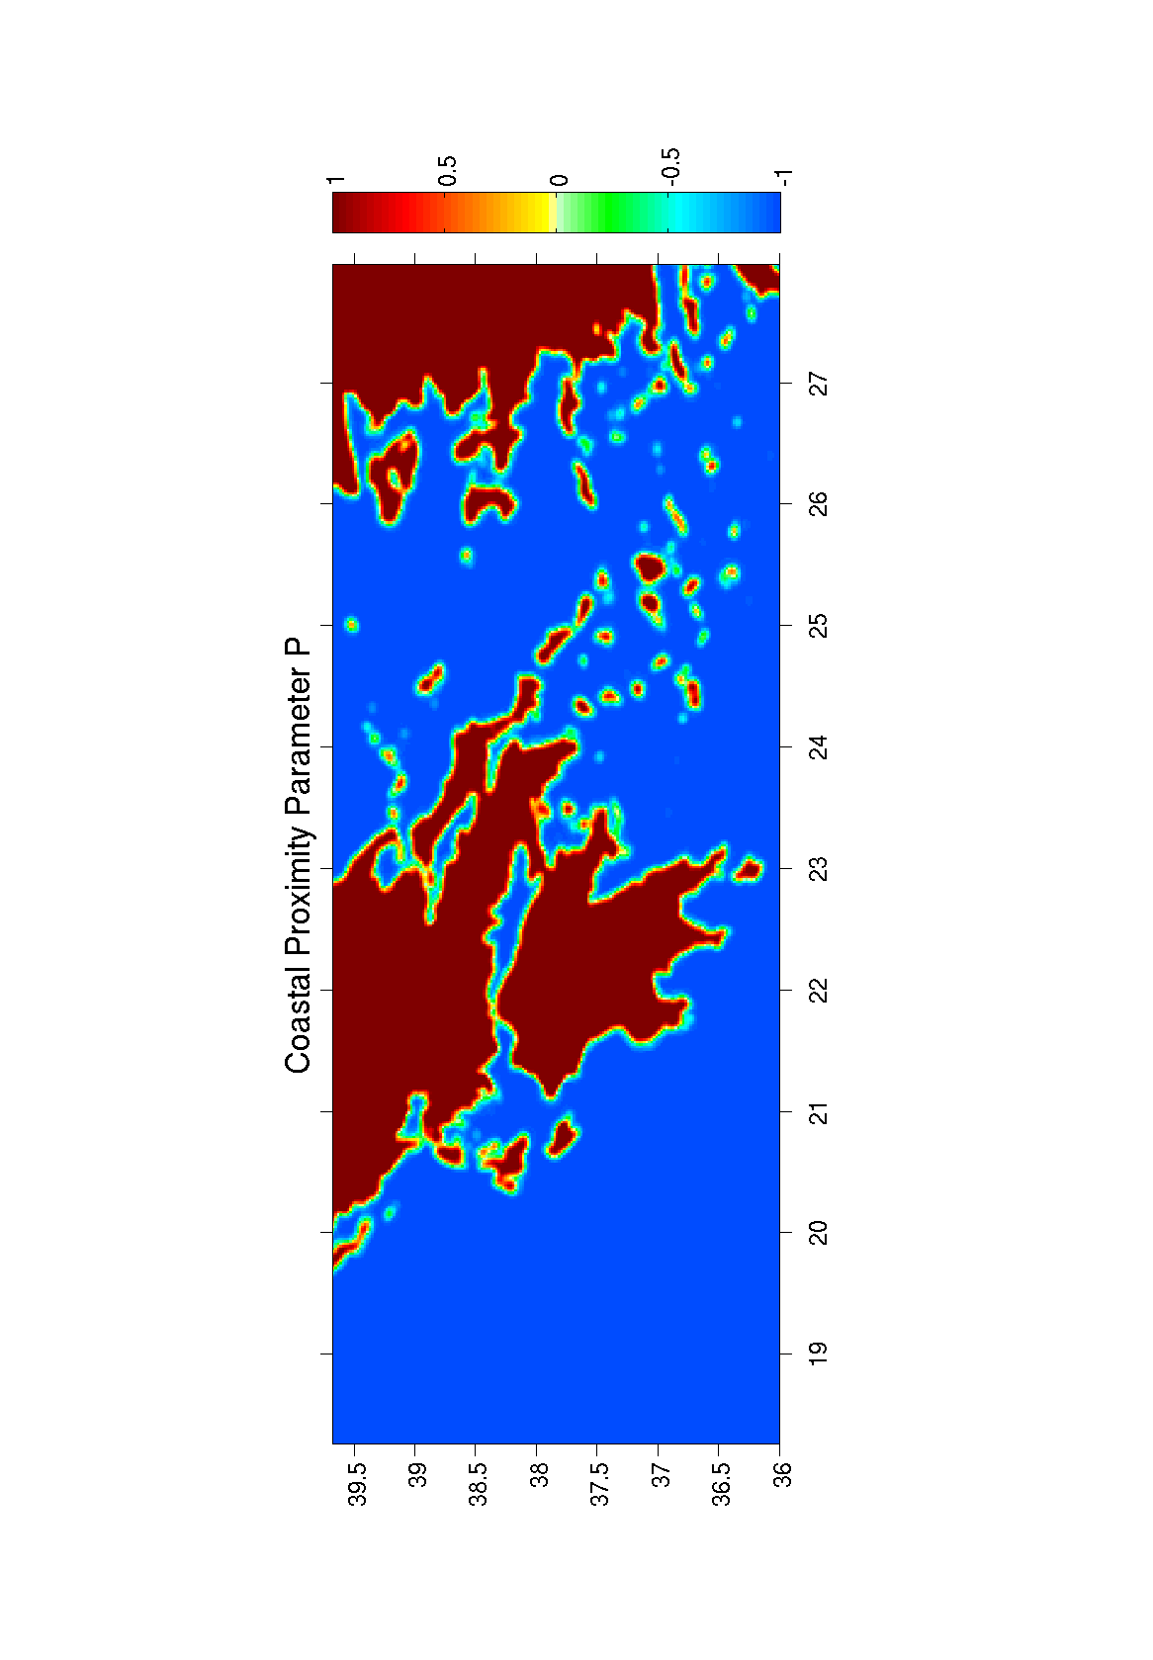
Recommendation
The GPD algorithm provides new estimations of the wet tropospheric correction in coastal areas. It has no impact on the global MSL trend estimation compared with the reference composite correction currently used in AVISO products. The MSL trend estimation is significantly modified in coastal areas with the GPD correction and it also improve the estimation of the sea level for mesoscale applications compared with the reference.
- Therefore we recommend to use the GPD algorithm for the estimation of the wet tropospheric correction for climate applications.
Open issues
- Interaction with COASTALT (ESA project) and PISTACH (CNES project)
Sea-level CCI ftp links
Validation reports:
- SLCCI-ValidationReport_WP2700_CoastalArea_WetTropo.docx
RRDP reports:
- RRDP_WP2700_Coast_GPD_vs_Composite_11_08_30.pdf
- RRDP_WP2700_Coast_GPD_vs_Radiometer_11_08_30.pdf
Technical document:
- Coastal proximity parameter: Day2_15_SLCCI_AR1_WP2700_CoastalProximity_NOC.pptx
- GPD algorithm: WP2710_Techical_Note_V1.docx

