
Consortium Members





ESA Sea Level CCI

Validation Report: WP2600 High latitudes areas
Reference: | CLS-DOS-NT-12-58
Nomenclature: | SLCCI-VR-26
Issue: | 1. 1
Date: | Mar. 12, 12

Chronology Issues:
Issue: | Date: | Reason for change: | Author
1.0 | 06/12/11 | Creation | L. Carrère
1.1 | 12/03/11 | Minor corrections and description of Mean Sea Surface evaluation | M.Ablain

People involved in this issue:
Written by (*): | L. Carrère, H. Roinard, M.Ablain (CLS) | Date + Initials:( visa or ref)
Checked by (*): | G Timms (Logica) | Date + Initial:( visa ou ref)
Approved by (*): | G Larnicol (CLS) | Date + Initial:( visa ou ref)
Application authorized by (*): | ESA | Date + Initial:( visa ou ref)
*In the opposite box: Last and First name of the person + company if different from CLS
Index Sheet:
Context: | Baghera tool, project ACT-OCEAN
Keywords: | Oceanography, sea level
Hyperlink:

Distribution:
Company | Means of distribution | Names
CLS | Notification

List of tables and figures

List of tables:
Aucune entrée de table d'illustration n'a été trouvée.
List of figures:
Figure 1: [Diagnostic A204a]: impact of tide models on regional MSL trends for ENVISAT and Jason-1 missions. 9
Figure 2: [Diagnosis A205] Amplitude differences of regional MSL annual signals using successively TPXO and GOT4.7 (on top) and DTU10 and GOT4.7 oceanic tidal models in the MSL calculation for Envisat (on left) and Jason-1 (on right). 10
Figure 3: [Diagnosis A205] Amplitude differences of regional MSL semi-annual signals using successively DTU10 and GOT4.7 oceanic tidal models in the MSL calculation for Envisat (on left) and Jason-1 (on right). 10
Figure 3: [Diagnosis A207] Differences of MSL variability computed with the tested models and with the GOT4.7 reference versus coastal distance for Envisat mission (left). 11
Figure 4: [Diagnosis A102] Differences of SSH crossovers computed with the TPXO7.2 model and with the GOT4.7 reference for Envisat mission. 12
Figure 5: [Diagnosis A102] Differences of SSH crossovers computed with the TPXO7.2 model and with the GOT4.7 reference for Jason-1 mission. 13
Figure 6: [Diagnosis A102] Differences of SSH crossovers computed with the DTU10 model and with the GOT4.7 reference for Envisat mission. 13
Figure 7: [Diagnosis A102] Differences of SSH crossovers computed with the DTU10 model and with the GOT4.7 reference for Jason-1 mission. 14
Figure 8: [Diagnosis A208] Differences of SLA computed with the TPXO7.2 model and with the GOT4.7 reference versus coastal distance for Envisat mission (left) and Jason-1 mission (right). 2
Figure 9: [Diagnosis A208] Differences of SLA computed with the DTU10 model and with the GOT4.7 reference versus coastal distance for Envisat mission (left) and Jason-1 mission (right). 2
Figure 10: [Diagnosis A209] Differences of SLA computed with the TPXO7.2 model and with the GOT4.7 reference for Envisat mission. 2
Figure 11: [Diagnosis A209] Differences of SLA computed with the TPXO7.2 model and with the GOT4.7 reference for Jason-1 mission. 2
Figure 12: [Diagnosis A209] Differences of SLA computed with the DTU10 model and with the GOT4.7 reference for Envisat mission. 2
Figure 13: [Diagnosis A209] Differences of SLA computed with the DTU10 model and with the GOT4.7 reference for Jason-1 mission. 3

List of items to be confirmed or to be defined

Lists of TBC:
Aucune entrée de table des matières n'a été trouvée.
Lists of TBD:
Aucune entrée de table des matières n'a été trouvée.
Applicable documents
AD 1 Sea level CCI project Management Plan
CLS-DOS-NT-10-013
Reference documents
RD 1 Manuel du processus Documentation
CLS-DOC
List of Contents
1. Introduction 5
1.1. Objectives 5
1.2. Studied Tide models 5
1.3. Mean Sea Surface 5
2. Global Mean Sea Level 7
2.1. Long-term evolution 7
2.1.1. Validation diagnoses used 7
2.1.2. TPXO7.2 and DTU10 Tide models 7
2.2. Inter-annual signals 7
2.2.1. Validation diagnoses used 7
2.2.2. TPXO7.2 and DTU10 Tide models 8
3. Regional Mean Sea Level 8
3.1. Long-term evolution 8
3.1.1. Validation diagnoses used 8
3.1.2. TPXO7.2 and DTU10 Tide models 8
3.2. Annual and semi-annual signals 9
3.2.1. Validation diagnoses used 9
3.2.2. TPXO7.2 and DTU10 Tide models 9
3.3. Coastal areas 11
3.3.1. Validation diagnoses used 11
3.3.2. TPXO7.2 and DTU10 Tide models 11
4. Mesoscale 12
4.1. Validation diagnoses used 12
4.2. Mean analyses 12
4.3. Coastal areas 14
4.3.1. Validation diagnoses used 14
4.3.2. TPXO7.2 and DTU10 Tide models 14
4.4. High latitudes 2
5. Conclusions and recommendations 3
5.1. Oceanic tidal models at high latitudes: 3
5.2. Mean Sea Surfaces 3
Appendix A - Synthesis 3
5.3. Envisat 4
5.4. Jason-1 5
Appendix B - Definition of the indicator value 6
Appendix C - List of acronyms 7

Introduction

Objectives
The main objective of this document is to provide the analysis of the Round Robin Data Packages (RRDP) reports dedicated to high latitude areas (WP2600). In the framework of the Sea-level CCI project, we have focused our analyses on dedicated tidal oceanic models in Arctic Ocean (TPX07.2 and DTU10), and new Mean Sea Surfaces significantly improved at these latitudes (CNES / CLS 2011 and DTU2010).
This document discuss the impact of all new algorithms separating the different climate applications defined in the sea level CCI URD (User Requirement Document) and separating the several temporal scales related with climate applications. A clearly and easily understandable impact indicator has been defined and is described in annex of this document (see Appendix B -).

Studied Tide models
Concerning high latitudes regions, the following Round Robin Data Packages (RRDP) reports have been performed where the study has been performed for latitudes higher than 50 degrees.
- Comparison of the TPXO7.2 tide model with the GOT4.7 tide model for Jason-1 and Envisat missions: RRDP_WP2600_HiLat_Tide_TPXO7V2_vs_GOT4V7_11-09-15.pdf
- Comparison of the DTU10 tide model with the GOT4.7 tide model for Jason-1 and Envisat missions:RRDP_WP2600_HiLat_Tide_DTU10_vs_GOT4V7_11-09-15.pdf

The GOT4.7 tide model is produced by produced by R. Ray. (See about the Got solution: (1999) “A global ocean tide model from Topex/Poseidon altimetry: GOT99.2.” NASA Tech Memo 209478: 58 pages).

The TPXO7.2 tide model is produced by Egbert et al., 2002; (see http://volkov.oce.orst.edu/tides/global.html). This model takes into account tide gauges data along the Russian coast. As this model does not include any load tide data, load tide effects from the FES2004 model had been used.

The DTU10 tide model is produced by Danmarks Tekniske Universitet. The DTU10 stands for global ocean tide model derived at DTU Space in 2010 using response method for residual analysis of multi-missions altimeter data. The extended global tidal model FES2004 (Finite Element Solutions) was used as a reference model. The model is an empirical ocean tide model and it includes load tide effects.

Mean Sea Surface
Mean Sea Surface have been developed in the frame of other projects: the Mean Sea Surface CNES / CLS 2011 performed in the frame of the SALP project and the Danish Technical University (DTU 2010).

MSS could have a strong impact on the SLA quality as for instance to better calculate the cross-track SLA gradients or to better calculate the SLA over area poorly sampled by altimetry measurements (ice areas and coastal areas). However the estimation of the quality and SLA performances of a new MSS is not trivial. The methodology developed in the frame of the See-Level CCI project (see Product Validation Plan document: PVP) could be applied but it is not completely adapted at this particular case.

Besides, a thorough comparison study has been performed between these MSS in the frame of the SALP project where dedicated analyses to the MSS have been performed:
- elementary statistics of the grid differences have been computed with various selections
- global grid differences have been compared with maps of the along track differences
- distinguish different range of frequencies of the along-track MSS differences (< 50 km and 50 / 500 have been distinguished
- the dependency of the MSS differences standard deviation with geophysical parameters has been discussed
.
Therefore for the estimation of the quality and the SLA performances of these new MSS, we have leant on this SALP report available here:
- SALP-NT-P-EA-22034-CLS-1-0.pdf

We have not produced classic RRDP reports as for others algorithms developed or used within the Sea-Level CCI project. We have summarized the mains results of this report in conclusion of this document.

Global Mean Sea Level

Long-term evolution

Validation diagnoses used
The validation diagnostic of the long-term sea-level evolution (A201-a) allows us to evaluate the impact on the global MSL trend using successively the different tidal model. Their impact is also analyzed separating descending and ascending passes (A201-b): the reduction of the MSL trend differences is a good quality criterion to determine which correction is the best one. Cross-comparison of MSL trends between altimetric missions collocated on the same period (B001) also give a relevant indication to know whether the potential drift of altimeter MSL is reduced or not with new correction.

TPXO7.2 and DTU10 Tide models
The following table indicates the impact of the tide model on global MSL trends for latitudes > 50°. According to the availability (or our interest) of the models, several RRDP may have been generated on different periods of a single altimetric mission.
The use of TPXO7.2 model has a significant impact on Envisat MSL trend estimation. Using DTU10 has no impact on Envisat. Differences observed between tidal models on Jason-1 are not significant, likely because only latitudes until 66° are observed due to the mission geometry.

Altimetric missions | GOT4.7 | TPXO7.2 | DTU10
Envisat (10:93) | -3.1 mm/yr | +0.19/GOT4.7 | -0.02/GOT4.7
Jason-1 (1:330) | +1.01 mm/yr | -0.051/GOT4.7 | +0.04 /GOT4.7
Table 1: [Diagnosis A201-a] Impact of the tide model on global MSL trends for LAT > 50°N.

Notice that in theory, the comparison of ascending/descending trend differences may contribute to assess whether the observed evolution of the trend is an improvement or not. But in case of the tidal models at high latitudes, the impact of each solution is not significant.

Inter-annual signals

Validation diagnoses used
The monitoring of the differences between both corrections (A001) but also of the variance differences of SLA (A202) may provide information concerning the impact of the studied correction on the global MSL at inter-annual time scales.

TPXO7.2 and DTU10 Tide models
Differences between studied models and GOT4.7 do not reveal any significant inter-annual signals.

Regional Mean Sea Level

Long-term evolution

Validation diagnoses used
The validation diagnosis of the regional trend of sea-level differences using successively tidal models (A204a) allows us to evaluate the impact of the different corrections on the local MSL trends. Their impact is also analyzed separating descending and ascending passes (A204b): the reduction of the MSL trend differences is a good quality criterion to determine the best correction. Cross-comparison of MSL trends evolution between altimetry missions collocated on the same period (B202) may also give a relevant indication of whether the potential MSL drift is reduced or not with the studied correction.

TPXO7.2 and DTU10 Tide models
The use of different tide models in the SSH calculation have an impact on the regional MSL trends. We observed MLS trend differences higher than 1 mm/yr in few areas close to the coasts or at very high latitudes. But the estimation of MSL trends in these areas is likely less accurate as a result of missing data due to the seasonal ice cover. Therefore regional MSL trend differences observed (plotted in following figures) for each mission do not provide very significant results.

Figure 1: [Diagnostic A204a]: impact of tide models on regional MSL trends for ENVISAT and Jason-1 missions.

Annual and semi-annual signals

Validation diagnoses used
The analyses of periodic signals of regional mean sea level are performed thanks to diagnostic A205 where the difference of amplitudes and phases between SLA using successively two tidal models are mapped for annual and semi-annual signals. These diagnostics allow us to characterize the local or regional impact of new corrections.

TPXO7.2 and DTU10 Tide models
Concerning annual signal, no significant annual or semi-annual signal is detected on Jason-1 and Envisat (Figure 2) . We have only observed differences ( > 0.5 cm) in areas where the data coverage is poor due to the ice coverage meaning that the estimation of periodic signals is bad with a strong formal error adjustment.
For the semi-annual signals, we observed similar results in areas impacted by ice coverage. In open ocean, we also observed smal amplitude differences between 0.5 cm and 1 cm for Envisat and Jason-1 using DTU10 instead of GOT4.7 (see )

Figure 2: [Diagnosis A205] Amplitude differences of regional MSL annual signals using successively TPXO and GOT4.7 (on top) and DTU10 and GOT4.7 oceanic tidal models in the MSL calculation for Envisat (on left) and Jason-1 (on right).

Figure 3: [Diagnosis A205] Amplitude differences of regional MSL semi-annual signals using successively DTU10 and GOT4.7 oceanic tidal models in the MSL calculation for Envisat (on left) and Jason-1 (on right).

Coastal areas

Validation diagnoses used
Mean and standard deviation of MSL (A207) are computed by using successively both altimetric components and they are plotted as a function of coastal distances between 0 and 100 km.

TPXO7.2 and DTU10 Tide models
Using TPX07.2 tends to raise the variability of the MSL signal when getting closer to the coast, while DTU10 tends to lower this variability particularly between 10-60 km from coast.
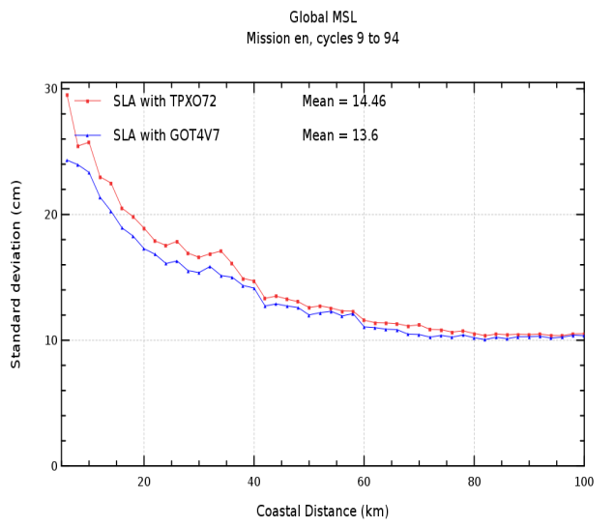 | 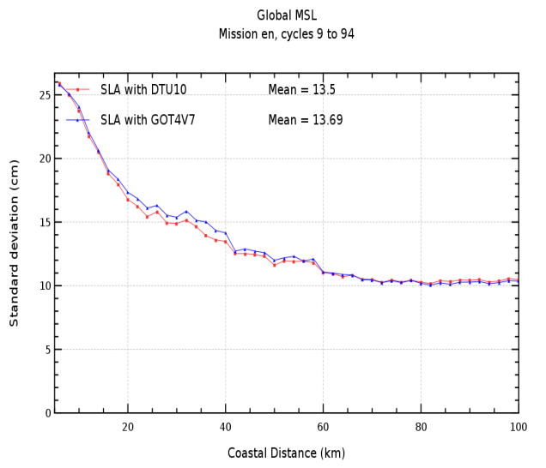
Figure 4: [Diagnosis A207] Differences of MSL variability computed with the tested models and with the GOT4.7 reference versus coastal distance for Envisat mission (left).

Mesoscale

Validation diagnoses used
Along-track sea-level analyses and differences at crossover points allow us to detect improvements at short temporal scales (< 2months) for mesoscale applications. The most relevant diagnostics performed in RRDP are the monitoring and the map of the variance SSH differences using successively 2 different tidal models.
Diagnostics A102 and A104 display the monitoring and the map of SSH variance differences at crossover points: the reduction of variance indicates a better homogeneity of the sea-level between ascending and descending tracks within a 10-day window.
Diagnostics A203 and A209 display the monitoring and the map of SSH variance differences relative to a mean sea surface (MSS): the reduction of variance indicates a better homogeneity with the MSS and most of the time, it indicates an improvement of the sea-level computation.

Mean analyses
Using TPXO7.2 model instead of GOT4.7 globally increases the SSH crossovers variance (+ 8.7 cm² for ENVISAT); this variance increase is greater for ENVISAT data than for Jason-1 likely due to the different geographical coverage of each mission.
Comparing DTU10 and GOT4.7 models, an annual signal is displayed with an increase (until 15 cm²) and a decrease (> 20 cm²) of the SSH crossovers variance. This annual signal is likely in realtion ship with the ice coverage. When the ice coverage is minimal (at the beginning of the fall in North hemisphere), new ocean area are observed by satellites where TPXO is better than GOT4.7. Performances of models are globally equivalent for ENVISAT mission although a small global improvement is observed for Jason-1.

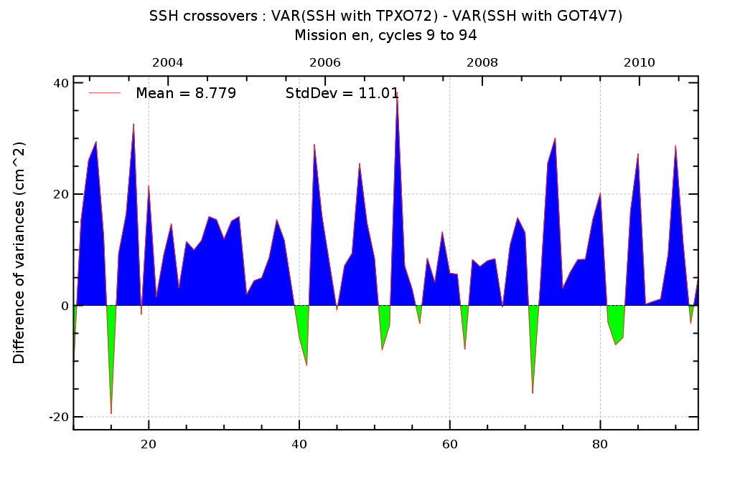
Figure 5: [Diagnosis A102] Differences of SSH crossovers computed with the TPXO7.2 model and with the GOT4.7 reference for Envisat mission.

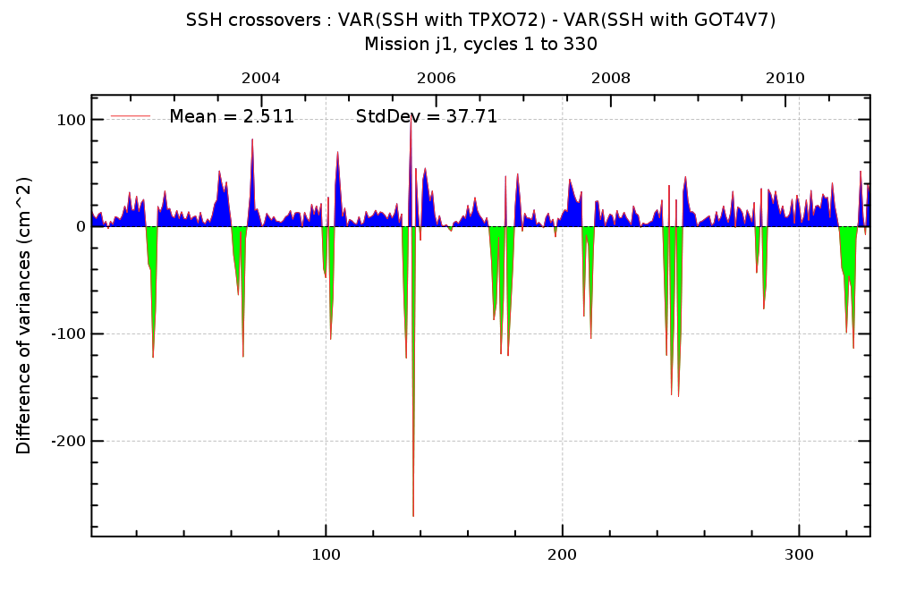
Figure 6: [Diagnosis A102] Differences of SSH crossovers computed with the TPXO7.2 model and with the GOT4.7 reference for Jason-1 mission.

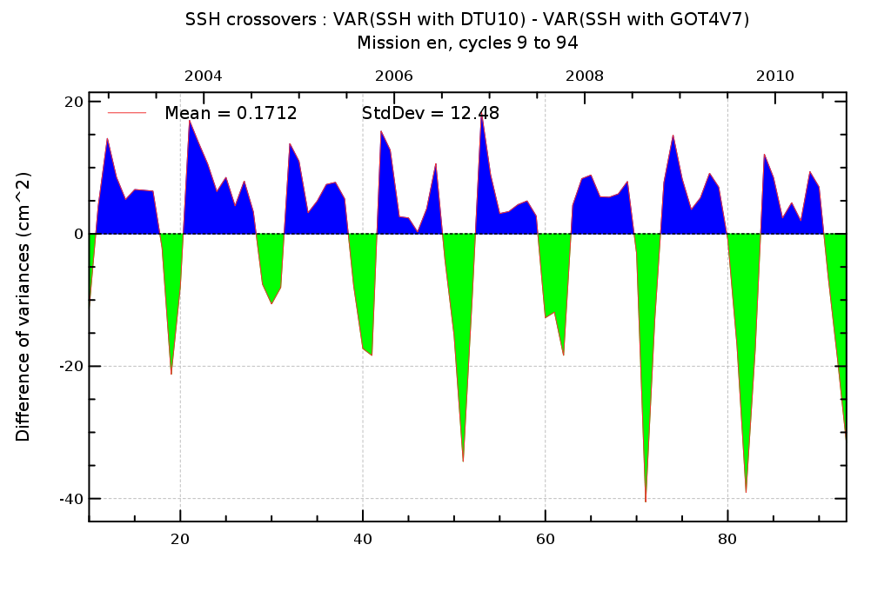
Figure 7: [Diagnosis A102] Differences of SSH crossovers computed with the DTU10 model and with the GOT4.7 reference for Envisat mission.

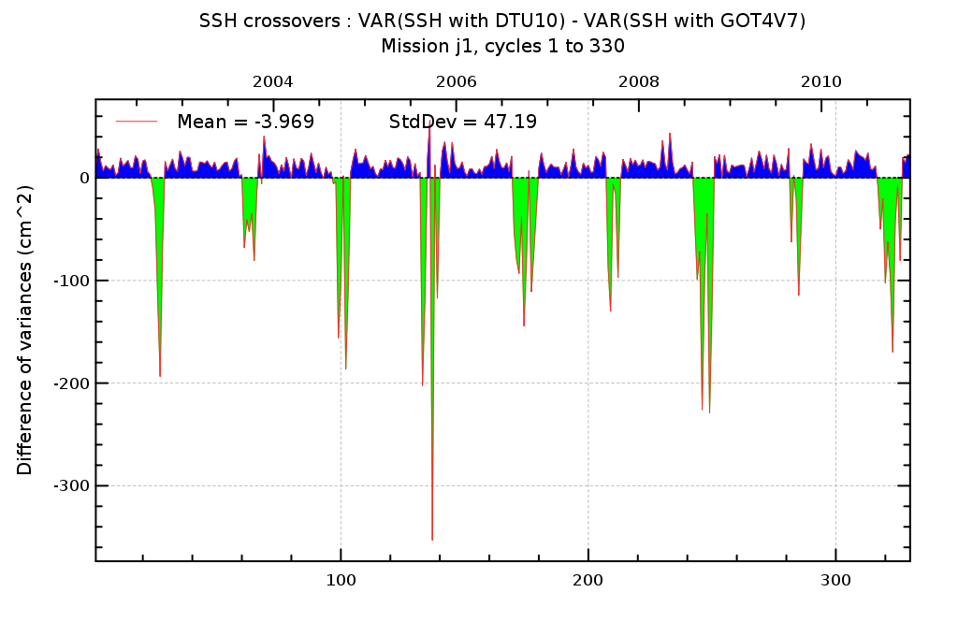
Figure 8: [Diagnosis A102] Differences of SSH crossovers computed with the DTU10 model and with the GOT4.7 reference for Jason-1 mission.

Coastal areas

Validation diagnoses used
The differences of SLA variances (A208) are computed by using successively both altimetric components and they are plotted as a function of coastal distances between 0 and 100 km.

TPXO7.2 and DTU10 Tide models
In case of TPXO7.2 model, variance of SLA with TPXO7.2 is greater than variance of SLA with GOT4.7, and differences are growing up as coastal distance is reduced.
Results show that DTU10 model has a positive impact on mesoscale estimation close to the coast: residual SLA variance is lower when using DTU10 instead of GOT4.7 and for costal distances lower than 60 km; for greater distances, DTU10 tends to raise the variance.

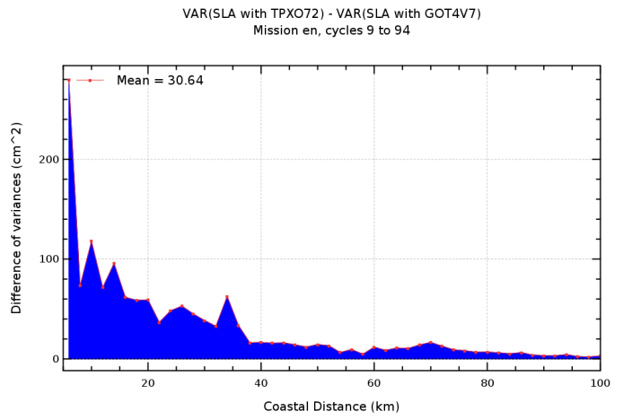
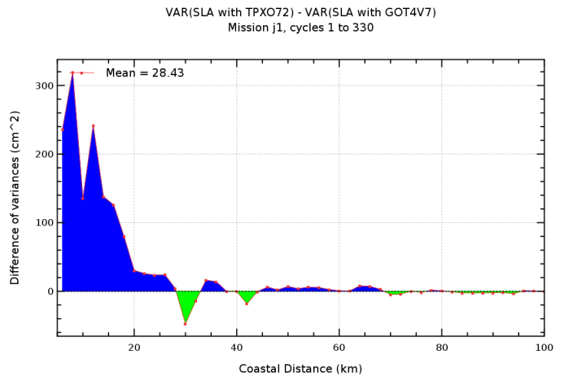

Figure 9: [Diagnosis A208] Differences of SLA computed with the TPXO7.2 model and with the GOT4.7 reference versus coastal distance for Envisat mission (left) and Jason-1 mission (right).

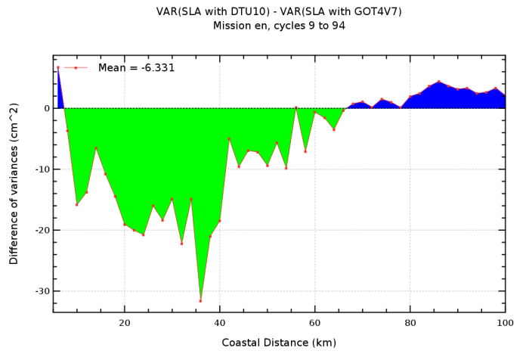

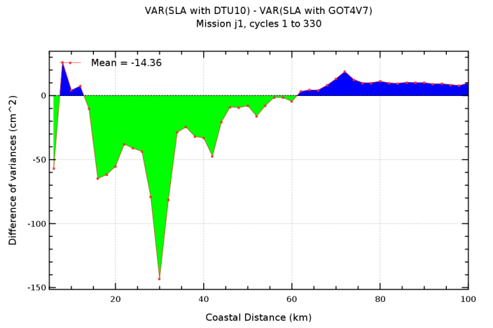

Figure 10: [Diagnosis A208] Differences of SLA computed with the DTU10 model and with the GOT4.7 reference versus coastal distance for Envisat mission (left) and Jason-1 mission (right).

High latitudes
The following figures represent the impact of the tidal models on SLA residual variance at northern high latitudes.
TPXO7.2 reduces the along-track SLA variance in the Arctic Ocean, north of Russia and Alaska, but it raises the variance in other coastal regions. Elsewhere in deep ocean results are similar to GOT4.7. DTU10 reduces the SLA variance in most of the Arctic Ocean and in northern part of Baffin bay; in northern Pacific and Atlantic oceans, DTU10 raises the residual variance if compared to GOT4.7.
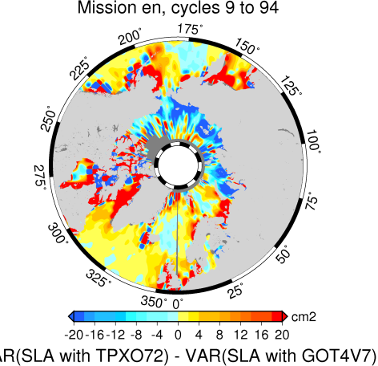
Figure 11: [Diagnosis A209] Differences of SLA computed with the TPXO7.2 model and with the GOT4.7 reference for Envisat mission.
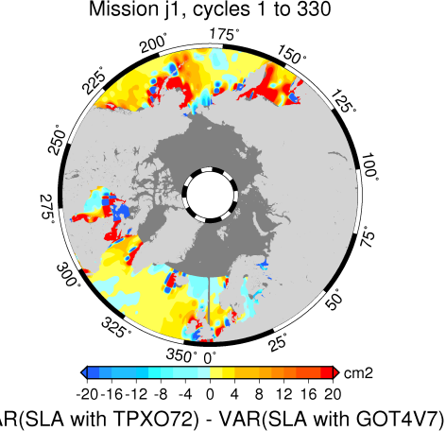
Figure 12: [Diagnosis A209] Differences of SLA computed with the TPXO7.2 model and with the GOT4.7 reference for Jason-1 mission.

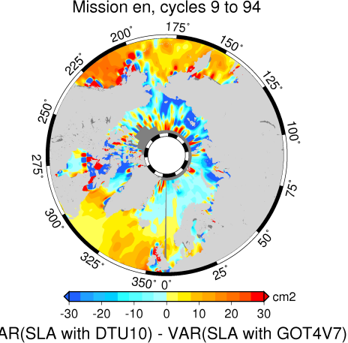
Figure 13: [Diagnosis A209] Differences of SLA computed with the DTU10 model and with the GOT4.7 reference for Envisat mission.
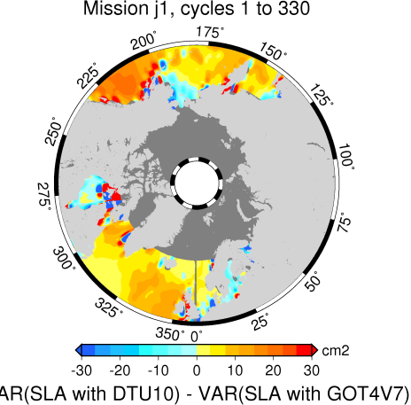
Figure 14: [Diagnosis A209] Differences of SLA computed with the DTU10 model and with the GOT4.7 reference for Jason-1 mission.

Conclusions and recommendations

Oceanic tidal models at high latitudes:
At high latitudes, the DTU10 tidal model in the Arctic area and northern very high latitudes regions provides a strong SSH variance reduction in these regions and it has also a significant impact on regional MSL (+/- 1 mm/yr).

- Therefore, concerning high latitudes we recommend to use the DTU10 tidal model in the Arctic area and northern very high latitudes regions

Mean Sea Surfaces

The MSS quality and their performances in the SLA calculation is provided in the SALP report (SALP-NT-P-EA-22034-CLS-1-0.pdf.

The differences between MSS CNES/CLS11 and DTU10 reveal that highest values of standard deviation (30.28 cm) are found for shallow waters (>-100m) and it is strongly reduced when limited to deep waters <-1000 m (6.20 cm) and to latitudes < 50° (5.93 cm). It is also reduced to 2.47 cm in regions of low latitudes, deep bathymetry and low ocean variability. However it increases to 17.24 cm when restricting to high latitudes (>±50°), suggesting that strong differences exist in these regions between MSS CNES/CLS11 and DTU10.

The global map of the difference between CNES/CLS11 and DTU10 (whatever the reference period is) reveals amplitude of ±1 to 2 cm with regional differences of up to ±3 to 5 cm at relatively long wavelengths such as in the western tropical Indian Ocean. Differences at smaller spatial scales are found in regions of high ocean variability with amplitude of up to ±7 to 10 cm. Stronger differences are also found at high latitudes. When focusing on short wavelengths, the only observed difference between CNES/CLS11 and DTU10 (whatever the reference period is) is of small amplitude (<2 cm) and is found at high latitudes and over gradient of bathymetry (ridges, geodesic features). Concerning longer wavelengths (50km to 500km), differences are observed in regions of high ocean variability and at high latitudes.

This MSS study have pointed out that the error associated with the processing of the inter annual content and the reference period of the MSS is estimated to be greater than the formal error of the MSS computation and this may have a strong impact for users of the MSS for oceanographic studies. The processing of the inter annual variability appears to be different in the computation of MSS CNES/CLS11 and DTU10. When both surfaces are referenced to the same time period, MSS CNES/CLS11 provides better SLA performances by ~1.7 cm rms in regions of low latitudes and low ocean variability in the open ocean. We show that MSS CNES/CLS11 is less sensitive to the ocean variability than DTU10: the MSS error increases with ocean variability and this increase is greater for DTU10 by 4% of the ocean variability than for CNES/CLS 11 when the analysis is made with Envisat data.

The analysis of MSS differences at high latitudes indicates that SLA performances are improved with CNES/CLS11 in the southern hemisphere (2.5 cm²) and that the difference is restricted to a small region of the northern hemisphere in the Laptev Sea. It is not attributed to the method of computation of the MSS but to the lack of input data for the CNES/CLS11 surface computation. In this small region, geoid values are used for CNES/CLS11 whereas IceSat measurements were used to compute DTU10 surface. Computing Envisat SLA with MSS after the 2010 orbit change indicates that SLA performances are deteriorated with a drifting orbit and the SLA increase after the orbit change is of 0.9 cm rms with CNES/CLS11 whereas it reaches 1.9 cm rms with CLS01, demonstrating the good quality of the new surface.

Finally, both MSS (DTU10 and CNES/CLS 2011) are complementary since at very high latitudes the DTU10 MSS provides better SLA performances whereas elsewhere (in open ocean) the CNES/CLS11 MSS is better.

- Therefore, we recommend to use the DTU10 MSS in order to favour the Arctic Ocean which is an area of main interest for climate studies. On the other hand, the use of the DTU10 MSS instead of CNES/CLS 2011 MSS reduce the SLA performances in open ocean which could have an impact on mesoscale applications. However, as the Sea-Level CCI products (ECV) are monthly products dedicated to climate studies, this impact will be very low.

- Synthesis
This section synthesizes the impact of all the new algorithms dedicated to the tide correction for each altimetric mission and separating the different climate applications defined in the sea level CCI URD (User Requirement Document). The impact is also estimated for several temporal scales impacting climate studies for each application.

In order to have a clear view of these potential impacts, the information is summarized in tables (one table per altimetric mission). An impact indicator clearly and easily understandable has been defined with 3 levels (when dedicated diagnostics are available): significant impact, low impact, no impact detected. Each level is represented by a different color box. The potential improvement or degradation is indicated when available with + /- signs.

The choice to decide of the value indicator (significant, low or null) is quite subjective. As it depends on the application (Global MSL, regional MSL, mesoscale…), the rule to classify this impact has been defined in annex of this document (see appendix).

Envisat
Envisat [October 2002- November 2010]
Climate  Applications | Temporal Scales | Round Robin Data Package (RRDP)
Climate  Applications | Temporal Scales | TPXO7.2 vs GOT4.7 |  |  |  | DTU10 vs GOT4.7
Global Mean Sea Level | Long-term evolution (trend)
Global Mean Sea Level | Inter annual signals (> 1 year)
Global Mean Sea Level | Annual, semi-annual signals
Regional Mean Sea Level | Long-term evolution (trend)
Regional Mean Sea Level | Annual, semi-annual signals
Mesoscale | < 2 months signals | -
Specific regional areas of main interest for climate studies:
Coastal areas | Long-term evolution (trend)
Coastal areas | Signals < 2 months | - |  |  | +
High latitudes | Long-term evolution (trend)
High latitudes | Signals < 2 months | + - |  |  | + + -
 |  | Significant impact | Low impact | No impact detected |  |  | Not yet evaluated
 |  | + | Positive impact (low)
 |  | - | Negative impact (significant)

Jason-1
Jason-1 [January 2002- December 2010]
Climate  Applications | Temporal Scales | Round Robin Data Package (RRDP)
Climate  Applications | Temporal Scales | TPXO7.2 vs GOT4.7 |  |  | DTU10 vs GOT4.7
Global Mean Sea Level | Long-term evolution (trend)
Global Mean Sea Level | Inter annual signals (> 1 year)
Global Mean Sea Level | Annual, semi-annual signals
Regional Mean Sea Level | Long-term evolution (trend)
Regional Mean Sea Level | Annual, semi-annual signals
Mesoscale | < 2 months signals | - |  |  | +
Coastal areas | Long-term evolution (trend)
Coastal areas | < 2 months signals | - |  |  | +
High latitudes | Long-term evolution (trend)
High latitudes | < 2 months signals | - |  |  | + - -
 |  | Significant impact | Low impact | No impact detected |  | Not yet evaluated
 |  | + | Positive impact (low)
 |  | - | Negative impact (significant)

- Definition of the indicator value
In this table, the choice of the indicator value is defined for each climate applications and temporal scales. The thresholds defined here are valid for time series long enough (> 7 years). If time series is too short, the thresholds have to be majored.

Climate  Applications | Temporal Scales | Definition of the indicator value
Climate  Applications | Temporal Scales | Significant impact | Low impact | No impact detected
Global Mean Sea Level | Long-term evolution (trend) | Trend >0.15 mm/yr | Trend> 0.05 mm/yr | Trend< 0.05 mm/yr
Global Mean Sea Level | Inter annual signals (> 1 year) | Amplitude> 0.5 mm | Amplitude> 0.2 mm | Amplitude< 0.2 mm
Global Mean Sea Level | Annual and semi-annual Signals | Amplitude> 1 mm | Amplitude> 0.2 mm | Amplitude< 0.2 mm
Regional Mean Sea Level | Long-term evolution (trend) | Trend > 0.5 mm/yr | Trend> 0.1 mm/yr | Trend< 0.1 mm/yr
Regional Mean Sea Level | Annual and semi-annual Signals | Amplitude> 5 mm | Amplitude> 0.5 mm | Amplitude< 0.5 mm
Mesoscale | Signals < 2 months | Crossovers Variance differences > 1 cm² | Crossovers Variance differences > 0.2 cm² | Crossovers Variance differences < 0.2 cm²
Specific regional areas of main interest for climate studies:
Coastal areas | Long-term evolution (trend) | Trend > 0.5 mm/yr | Trend> 0.1 mm/yr | Trend< 0.1 mm/yr
Coastal areas | Signals < 2 months | Crossovers Variance differences > 1 cm² | Crossovers Variance differences > 0.2 cm² | Crossovers Variance differences < 0.2 cm²
High latitudes | Long-term evolution (trend) | Trend > 0.5 mm/yr | Trend> 0.1 mm/yr | Trend< 0.1 mm/yr
High latitudes | Signals < 2 months | Crossovers Variance differences > 1 cm² | Crossovers Variance differences > 0.2 cm² | Crossovers Variance differences < 0.2 cm²

- List of acronyms

TBC | To be confirmed
TBD | To be defined
AD | Applicable Document
RD | Reference Document

